**Experiment 1:**

**DESIGN A WEB PAGE USING BASIC HTML TAGS**

**Aim:** To design a web page using the basic HTML tags

**Description:**

|  |  |
| --- | --- |
| **HTML Tag** | **Description** |
| [**<!DOCTYPE>**](https://www.w3schools.com/tags/tag_doctype.asp) | Defines the document type |
| [**<html>**](https://www.w3schools.com/tags/tag_html.asp) | Defines an HTML document |
| [**<head>**](https://www.w3schools.com/tags/tag_head.asp) | Defines information about the document |
| [**<title>**](https://www.w3schools.com/tags/tag_title.asp) | Defines a title for the document |
| [**<body>**](https://www.w3schools.com/tags/tag_body.asp) | Defines the document's body  **Attributes**  background - background image for a document  bgcolor: background color of a document |
| [**<h1> to <h6>**](https://www.w3schools.com/tags/tag_hn.asp) | Defines HTML headings |
| **<mark>** | highlight parts of text |
| [**<p>**](https://www.w3schools.com/tags/tag_p.asp) | Defines a paragraph |
| **<a>** | Defines a hyperlink, which is used to link from one page to another.  **Attributes**  href - URL of the page the link goes to  name - name of an anchor tag  target - where to open the linked document. Possible values are blank, parent, self, top |
| [**<br>**](https://www.w3schools.com/tags/tag_br.asp) | Inserts a single line break |
| [**<hr>**](https://www.w3schools.com/tags/tag_hr.asp) | Defines a thematic change in the content |
| [**<!--...-->**](https://www.w3schools.com/tags/tag_comment.asp) | Defines a comment |
| **<img>** | defines an image  **Attributes**  align - alignment of an image according to surrounding elements. The possible values are top, bottom, middle, left right  alt - an alternate text for an image  border - width of the border around an image  height - height of an image  hspace - whitespace on left and right side of an image  src - URL of an image  vspace - whitespace on top and bottom of an image  width - width of an image |
| **<ol>** | Defines an ordered list  ‘type’ attribute for <ol> tag to specify the type of numbering  Following are the possible options .By default, it is a number.  <ol type = "1"> - Default-Case Numerals.  <ol type = "I"> - Upper-Case Numerals.  <ol type = "i"> - Lower-Case Numerals.  <ol type = "A"> - Upper-Case Letters.  <ol type = "a"> - Lower-Case Letters.  ‘start’ attribute for <ol> tag to specify the starting point of numbering  <ol type = "1" start = "4"> - Numerals starts with 4.  <ol type = "I" start = "4"> - Numerals starts with IV.  <ol type = "i" start = "4"> - Numerals starts with iv.  <ol type = "a" start = "4"> - Letters starts with d.  <ol type = "A" start = "4"> - Letters starts with D. |
| **<li>** | Defines a list item |
| **<ul>** | Defines an unordered list  ‘type’ attribute for <ul> tag to specify the type of bullet. Following are the possible options. By default, it is a disc.  <ul type = "square">  <ul type = "disc">  <ul type = "circle"> |
| **<dl>** | Defines a description list |
| **<dt>** | Defines a term/name in a description list |
| **<dd>** | Describes each term/name |
| **<table>** | Defines a table  **Attributes**:  align - the alignment of a table according to surrounding text  (left/center/right)  bgcolor - the background color for a table  border - borders around the table and the table’s cells  cellpadding- space between the cell wall and the cell content  cellspacing- space between cells  colspan - number of columns a table cell should span  rowspan - number of rows a table cell should span  width - width of a table (pixels or %) |
| **<caption>** | Defines a table caption |
| **<th>** | Defines a header cell in a table |

|  |  |
| --- | --- |
| **<tr>**  **<td>**  **<thead>**  **<tbody>**  **<tfoot>** | Defines a row in a table  Defines a cell in a table  Groups the header content in a table  Groups the body content in a table  Groups the footer content in a table |

**Program:**

<html>

<head>

<title>Web Technology - Online Content</title>

<style type="text/css">

</style>

</head>

<body bgcolor="#ffcb1">

<div align="center"><h1>

<font color="white">14ITT52 &nbsp;&dash;&nbsp;Web Technology&ndash;Usage of Basic Tags</font></h1>

</div>

<div>

<div align="left" ><h3><b><font color="green">UNIT I&nbsp;&dash;&nbsp; HTML</font></b></h3>

</div>

<ul>

<li><a href="#comp">Introduction to Computers and the Internet</a></li>

<li><a href="#htm">HTML5</a></li>

<li><a href="basic tags.html" target="blank">Basic Tags</a></li>

<ul>

<li>Links</li>

<li><a href="basic tags.html#img" target="blank">Images</li>

</ul>

<li><a href="#IPTags">Input Tags</a></li>

<li><a href="pse.html">Page structured element</a></li>

<li><a href="#cssP1">Cascading Style Sheet –Part I</a></li>

</ul>

<div align="left"><h3><b><font color="green">UNIT&nbsp;II&dash;&nbsp; Client Side Scripting</font></b></h3></div>

<ul>

<li>Introduction to Java Script</li>

<li>Control Statements I</li>

<li>Control Statements II</li>

<li>Functions</li>

<li>Arrays</li>

</ul>

<div align="left"><h3><b><font color="green">UNIT III &nbsp;&dash;&nbsp; Java Script Objects</font></b></h3></div>

<ul>

<li>Objects</li>

<li>Document Object Model</li>

<ul>

<li>Objects and Collections</li>

<li>Events</li>

<li>Event Handling</li>

</ul>

</ul>

<div align="left"><h3><b><font color="green">UNIT IV&nbsp;&dash;&nbsp; Web Server</font></b></h3></div>

<ul>

<li>Introduction</li>

<li>HTTP Transaction</li>

<li>Multi Tier Application Architecture</li>

<li>Accessing Web Server</li>

<li>Apache</li>

<li>MySQL</li>

<li>PHP Installation</li>

<li> Microsoft IIS Server</li>

<li>AJAX</li>

<li> XMLHttpRequest</li>

</ul>

<div align="left">

<h3><b><font color="green">UNIT V&nbsp;&dash;&nbsp; Server Side Scripting</font></b></h3>

</div>

<ul>

<li>PHP </li>

<li>Introduction</li>

<li>Operators</li>

<li>Arrays</li>

<li>Strings</li>

<li>Regular Expressions</li>

<li>Form Processing</li>

<li> Database Connectivity </li>

<li>Session Tracking</li>

</ul>

</div>

<div>

<h2><font color="brown"><b>Chapter 1</b></font></h2>

<dl>

<dt ><h3>Introduction to Computers and the Internet</h3></dt>

<dd id="comp">

<p>In the past, most computer applications ran on computers that were not connected to

one another, whereas today’s Internet applications can be written to communicate among

computers throughout the world. We rely on computers and the Internet to communicate, navigate, collaborate and

more. Table 1.1 gives some examples of how computers and the Internet provide the

infrastructure for these tasks.

<table border="3" cellspacing="2" cellpadding="5" bgcolor="lightgreen">

<tr bgcolor="white" valign="center" >

<th>Name</th>

<th>Description</th>

</tr>

<tr bgcolor="pink" valign="center" >

<td ><a href="Docs/CC-1.pptx">

Cloud Computing</a></td>

<td><p align="justify">Allows you to use software, hardware and information

stored in the “cloud”—i.e., accessed on remote computers via the Internet

and available on demand—rather than having it stored on your personal

computer. Cloud computing provides resources as services and is based on pay-per use model. These services, allowing you

to increase or decrease resources to meet your needs at any given time, are

generally more cost effective than purchasing expensive hardware to ensure

that you have enough storage and processing power to meet your needs at

their peak levels.</p></td>

</tr>

<tr valign="center" >

<td>GPS</td>

<td><p align="justify">Global Positioning System (GPS) devices use a network of satellites to

retrieve location-based information. Multiple satellites send time-stamped

signals to the GPS device, which calculates the distance to each satellite

based on the time the signal left the satellite and the time the signal arrived.

This information is used to determine the exact location of the device.</p></td>

</tr>

<tr bgcolor="pink" valign="center" >

<td>Robots</td>

<td><p align="justify">Robots can be used for day-to-day tasks (e.g., iRobot’s Roomba vacuum),

entertainment (e.g., robotic pets), military combat, deep sea and space

exploration (e.g., NASA’s Mars rover) and more.</p></td>

</tr>

<tr valign="center" >

<td>

E-mail, Instant

Messaging,

Video Chat

and FTP

</td>

<td>

<p align="justify">Internet-based servers support all of your online messaging. E-mail messages

go through a mail server that also stores the messages. Instant messaging

(IM) and Video Chat apps, such as AIM, Skype, Yahoo! Messenger and others

allow you to communicate with others in real time by sending your messages

and live video through servers. FTP (file transfer protocol) allows you

to exchange files between multiple computers (e.g., a client computer such

as your desktop and a file server) over the Internet using the TCP/IP protocols

for transferring data.

</p>

</td>

</tr>

</table>

</dd>

<dt id="htm"><h3>HTML5</h3></dt>

<dd><dl><dt><font size="4"><b><i>Introduction</i></b></font></dt>

<dd>HTML5 is a markup language that specifies the structure and content of documents that

are displayed in web browsers. Some basics HTML5 techniques are:

<ul>

<li><i><b>tables</b></i> - for structuring information from databases</li>

<li><i><b>forms</b></i> - to collect information from web-page visitors</li>

<li><i><b>internal and external links</b></i> - for easier page navigation</li>

<li><i><b>meta elements</b></i> - for specifying information about a document</li>

</ul>

</dd>

<dt><font size="4"><b><i>Editing HTML5</i></b></font></dt>

<dd>

<p align="justify">HTML5 documents are created by typing HTML5 markup text in a text editor (such as Notepad, TextEdit, vi, emacs) and saved with the .html or .htm filename extension. They are stored in computers called web servers and the Clients can request the documents through web browsers running on your local computer or smartphone</p>

</dd>

<dt><font size="4"><b><i>First HTML5</i></b></font></dt>

<dd>

<p align="justify">Following figure shows a simple HTML5 document named main.html</p>

<img src="../Images/intro.gif"/>

</dd>

<dt><font size="4"><b><i>Headings</i></b></font></dt>

<dd>

<p align="justify">

HTML5 provides six heading elements (h1 through h6) for specifying the relative importance of information. Heading element h1 is considered the most significant one and is typically rendered in a larger font than the other five. Each successive heading element is typically rendered in a progressively smaller font. Following figure describes the usage of the heading elements:

</p>

<img src="../Images/headings.gif"/>

</dd>

</dl>

</dl>

</div>

</body>

</html>

**Output:**

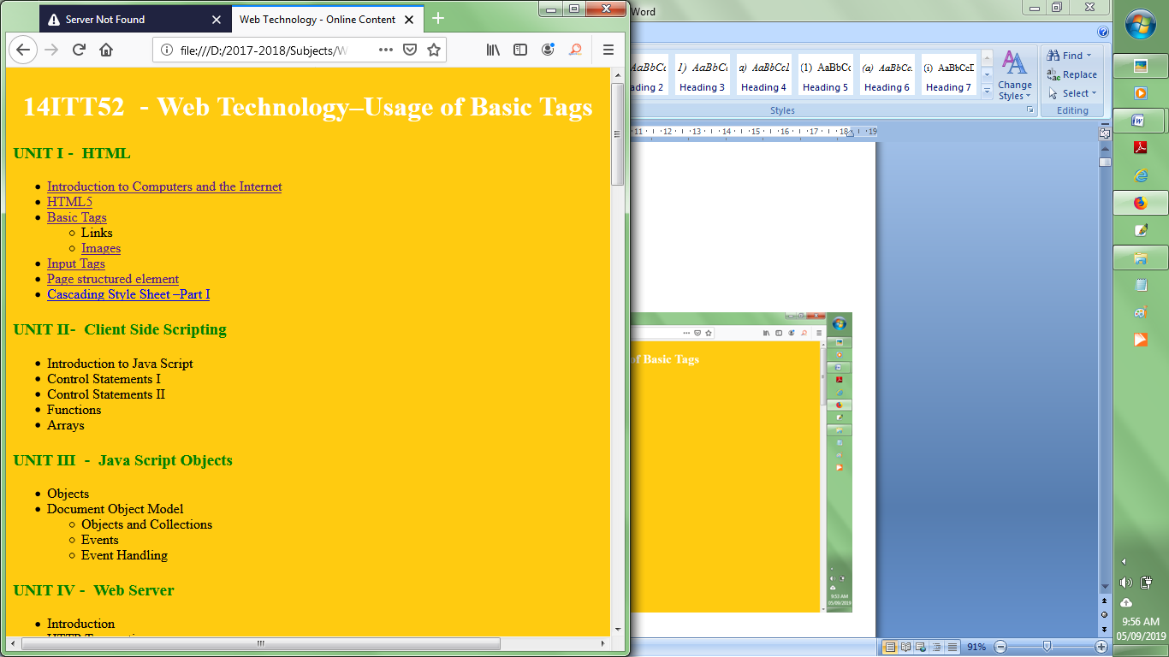

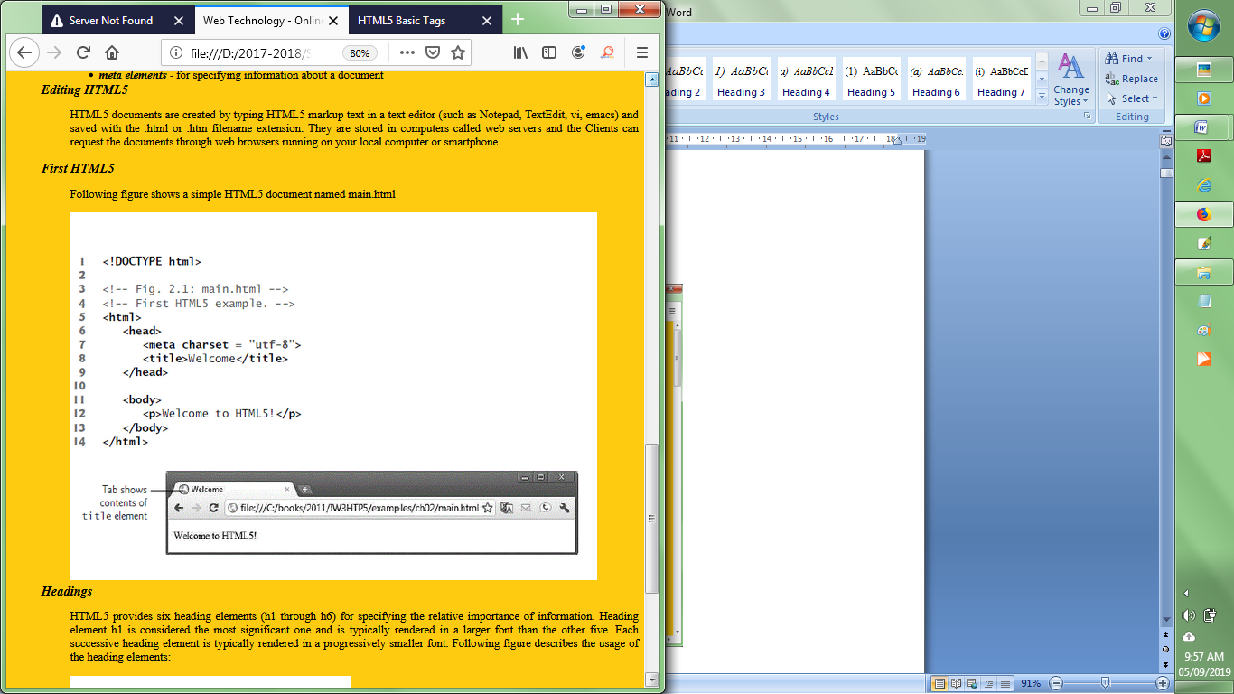

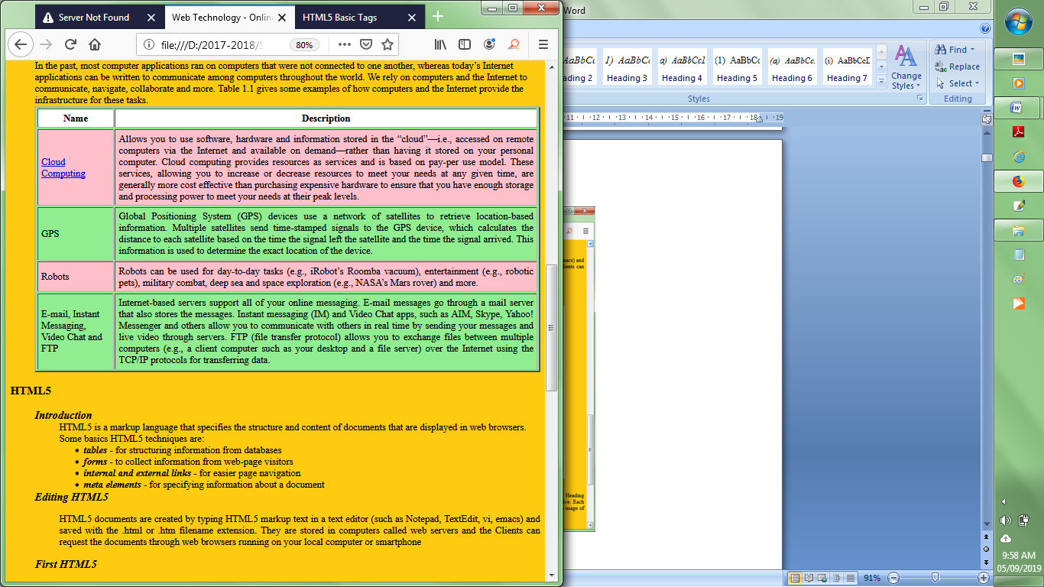

**Result:**

Thus a web page has been designed using the basic HTML Tags.

**VIVA Questions**

1. Write a HTML code to display your department name as a heading in different sizes.
2. How do you make use of a picture as a background image of a web page?
3. Identify each of the following items as either a HTML5 element or an attribute:

|  |  |
| --- | --- |
| 1. htlm 2. width 3. href 4. br 5. h3 | 1. a 2. src 3. name 4. select 5. type |

1. How do you insert a copyright symbol on a browser page?
2. Write a HTML document to create links to sections within the same page?
3. Create an HTML document containing an ordered list of three items—ice cream, soft serve and frozen yogurt. Each ordered list should contain a nested, unordered list of your favourite flavors. Provide three flavors in each unordered list.
4. Use the correct HTML attribute to make the link open in a new window.

**<a href="html_images.asp" ________________>HTML Images</a>**

1. Create the following table format

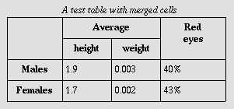

1. Write a HTML document to Insert an image and create a link such that clicking on image takes user to other page
2. Create the HTML5 markup that displays the following table on a web page.



**Experiment 2:**

**DESIGN A WEB PAGE USING DIFFERENT TYPES OF CSS**

**Aim:** To design a web page by applying different types of CSS.

**Description:**

**CSS**

CSS stands for Cascading Style Sheets, which describes how HTML elements are to be displayed on screen, paper, or in other media. It defines styles for web pages, including the design, layout and variations in display for different devices.

**CSS Syntax**

A CSS rule-set consists of a selector and a declaration block:

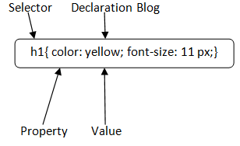

* The selector points to the HTML element you want to style.
* The declaration block contains one or more declarations separated by semicolons.
* Each declaration includes a CSS property name and a value, separated by a colon.

|  |  |
| --- | --- |
| **CSS Selectors** | **Select HTML elements according to its id, class, type, attribute etc.** |
| **Element Selector** | Selects the HTML element by name. |
| **Id Selector** | Selects the id attribute of an HTML element to select a specific element. An id is always unique within the page so it is chosen to select a single, unique. It is written with the hash character (#), followed by the id of the element |
| **Class Selector** | selects HTML elements with a specific class attribute. It is used with a period (.) character followed by the class name. A class name should not be started with a number. |
| **Universal Selector** | used as a wildcard character. It selects all the elements on the pages. |
| **Group Selector** | Select all the elements with the same style definitions. Grouping selector is used to minimize the code. Commas are used to separate each selector in grouping. |

**There are three ways to associate styles with HTML document.**

1. Inline style sheet

2. Embedded style sheet / Internal style sheet

3. External style sheet

**Inline style sheet**

Use style attribute of any HTML element to define style rules. These rules will be applied to that element only.

<h1 style ="color:pink"> This is inline CSS </h1>

**Embedded style sheet/Internal style sheet**

CSS rules to be available inside of <style> element and this tag is placed inside the <head>...</head> tags. Rules defined using this syntax will be applied to all the elements available in the document.

<head>

<style type="text/css" >

h1{

color: pink;

}

</style>

</head>

**External style sheet**

The <link> element can be used to include an external stylesheet file in the HTML document.

An external style sheet is a separate text file with .css extension and it contains all the Style rules. This can be used to apply similar styles to multiple documents with <link> element.

mystyle.css

h1, h2, h3 {

color: red;

…

}

mystyle.css linked in head part of the any HTML document as follows:

<head>

<link rel="stylesheet" type="text/css" href="mystyle.css" />

</head>

|  |  |  |
| --- | --- | --- |
| **CSS Properties** | **Values** | **Description** |
| position | static, relative, fixed  absolute, sticky | Specifies the type of positioning method used for an element. |
| overflow | visible, hidden, scroll  auto | Add scrollbars when the content of an element is too big to fit in the specified area. |
| float | left, right, inherit, none | Used for positioning and formatting content |
| display | none, block, inline  inline-block | specifies how an element is displayed |

|  |  |  |
| --- | --- | --- |
| list-style-type | none | specifies the type of list item marker |
| z-index | number | Specifies the stack order of an element.  Element with greater stack order is always in front of an element with a lower stack order |
| padding | padding-top  padding-right  padding-bottom  padding-left | generate space around an element's content |
| border | dotted, dashed, solid  none | Specify the style, width, and color of an element's border |

|  |  |
| --- | --- |
| **CSS Selector** | **Description** |
| :hover | specifies mouse over link |
| :link | specifies unvisited link |
| :visited | specifies visited link |
| :active | specifies selected link |

**Program:**

<html>

<head><title>CSE Home Page</title></head>

**<!--External Style Sheet-->**

<link rel="stylesheet" type="text/css" href="navBar.css">

<style>

**<!--Embedded Style Sheet-->**

#header{

position:relative;

top:-50px;

}

.main_content{

position:absolute;

padding-top:10px;

background-color:rgb(154,191,229);

//opacity:0.5;

height:550px;

width:78%;

left:275px;

top:200px;

}

.sidenav{

position:absolute;

size:35% 100%;

background-color:black;

top:200px;

}

.sidenav a{

display:block;

padding:10px 15px;

color:rgb(0,110,185);

font-size:15pt;

font-weight:bold;

text-decoration:none;

border-bottom-style:solid;

border-bottom-width:2px;

}

.sidenav a:hover{

background-color:lightgrey;

color:blue;

}

h3{

position:relative;

top:0;

width:150px;

font-family:cambria;

color:white;

margin-left:15px;

background-color:black;

}

p{

text-indent:25px;

}

p, li{

text-align:justify;

font-family:cambria;

font-size:13pt;

margin-left:15px;

}

img{

//float:right;

overflow:auto;

}

#footer{

position:relative;

bottom:-600px;

//background-color:green;

width:100%;

height:5%;

}

.hods_msg{

position:relative;

margin-top:250px;

}

#footer p{

text-align:center;

color:white;

background-color:blue;

}

article{

float:left;

position:absolute;

left:260px;

top:200px;

background-color:lightgrey;//rgb(199,251,204);

width:1000px;

height:100%;

}

section{

width:400px;

float:left;

padding:30px;

}

</style>

<body>

<div id="header">

**<!--Inline Style Sheet-->**

<div style="height:30%;width:100%;">

<h1 style="color:white;font-size:50pt;background-color: rgb(0,110,185); width:50%;height:100%">

Computer Science<br/> and Engineering</h1>

<img src="../Images/bgst1.jpg" width="650px" height="185px" style="border: 1px solid #ddd; border-radius:10px;position:absolute; top:5px;right:0;opacity:.6"/>

</div>

<div class="content">

<div class="sidenav">

<a href="cse_home.html">Home</a>

<a href=" ">Highlights</a>

<a href=" ">Students Activities </a>

<a href=" ">Department Library</a>

</div>

<aside class="hods_msg">

<figure style="position:absolute;left:-38px;">

<figcaption style="font-size:20pt;background-color:black;text- align:center;color:white;font-family:cambria;">

HoD's Desk</figcaption>

<img src="../Images/rrr.png" height="250px" width="210px"/>

</figure>

</aside>

<article>

<h3>About CSE</h3>

<p>Department of CSE was started in the year 1988

with B.E. Programme. With the increasing demand in Computer

Science and Engineering, M.E programme was started in the year

1999. The department is recognized to offer research

programme leading to Ph.D. The department aims at developing

intellectually alert, scientifically progressive, globally competent

and dynamic young IT professionals.

</p>

<h3>Vision</h3>

<p>To be a centre of excellence for nurturing competent computer professionals of high calibre and quality for catering to the ever-changing needs of the industry and society

</p>

<h3>Mission</h3>

<p>Department of Computer Science & Engineering is committed to

<ul>

<li>Develop innovative, competent and ethically strong computer engineers to meet global challenges.</li>

<li>Foster consultancy and basic as well as applied research activities to solve real world problems.</li>

<li>Endeavour for constant upgradation of technical expertise to cater to the needs of the industry and society</li>

</ul>

</p>

</article>

</div>

<div id="footer"><p>Maintained by KEC Web Group</p>

</div>

</div>

</body>

</html>

***navBar.css***

#header{

position:relative;

top:-50px;

}

.nav{

position:absolute;

top:143px;

right:0;

margin-right:8px;

}

.nav ul {

list-style-type: none;

z-index:1;

margin: 0;

padding: 0;

overflow:hidden;

background-color: rgb(e0,110,185);

}

.nav ul li {

float: left;

font-size:15pt;

font-weight:bold;

font-family:cambria;

padding:6px 10px;

background-color: black;

}

li a{

color:white;

text-decoration:none;

}

.menu:hover{

color:black;

background-color:blue;

}

.submenu{

display: none;

position: relative;//absolute;

margin-left:-15;

float:left;

top:120px;

background-color:white;

z-index: 1;

width:167px;

}

.submenu a {

color: black;

padding: 6px 15px;

text-decoration: none;

display: block;

text-align: left;

}

.menu:hover .submenu{

display:block;

background-color:blue;

position:relative;

top:20px;

}

.submenu a:hover {

background-color:lightgrey;//white;

}

.ssmenu{

display: none;

position: absolute;

margin-left:170;

top:40;

z-index: 1;

width:167px;

}

#sccs:hover .ssmenu{

display:block;

background-color:lightgrey;

}

.ssmenu a:hover {

background-color:rgb(0,110,185);

}

li a{

color:rgb(0,110,185);

text-decoration:none;

}

.menu:hover{

color:black;

background-color:lightgrey;

}

.submenu{

display: none;

position: absolute;

margin-left:-15;

top:30px;

background-color:white;

//z-index: 1;

width:167px;

}

.submenu a {

color: black;

padding: 6px 15px;

text-decoration: none;

display: block;

text-align: left;

}

.menu:hover .submenu{

display:block;

background-color:rgb(0,110,185);

}

.submenu a:hover {

background-color:lightgrey;//white;

}

.ssmenu{

display: none;

position: absolute;

margin-left:170;

top:70;

z-index: 1;

width:167px;

}

#sccs:hover .ssmenu{

display:block;

background-color:lightgrey;

}

.ssmenu a:hover {

background-color:rgb(0,110,185);

}

**Output:**



**Result:**

Thus a web page is designed by applying the different types of CSS.

**Viva Questions**

1. **How do you make a rounded corner by using CSS?**
2. Consider the following HTML/CSS code:

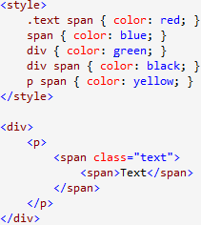

What color will be applied to the text?

1. Display image and a text overlapping on each other.
2. Demonstrate the difference between visibility: hidden and display:none.
3. Name three ways to define a color in html.
4. How to create a scrollable content?
5. Write CSS Script to make an image remain in place when the user scrolls up or down.
6. Write a CSS rule that changes the color of all elements containing attribute class = "green-Move" to green and shifts them down 25 pixels and right 15 pixels.
7. Create two paragraphs and line them as columns side by side.
8. Create a rule that displays all links in blue without underlining them.

**Experiment 3:**

**DESIGN A WEB PAGE WITH MENU LAYOUT USING CSS**

**Aim:** To design a web page with menu layout using appropriate CSS properties.

**Description:**

|  |  |  |  |
| --- | --- | --- | --- |
| **HTML Tags That Can Be Used** | | | |
| **Tags** | **Description** | | |
| <div> | Specifies a division or a section in an HTML document – used to enclose the menubar | | |
| <nav> | Defines a set of navigation links. | | |
| <ul>, <ol>, <li> | Defines a ordered or unordered list – used to design menubar | | |
| <a> | Specifies a link from one page to another | | |
| **CSS Properties Applied** | | | |
| **Properties** | | **Values** | **Description** |
| position | | static, relative, fixed, absolute, sticky | Specifies the type of positioning method used for an element. |
| overflow | | visible, hidden, scroll, auto | Add scrollbars when the content of an element is too big to fit in the specified area. |
| float | | left, right, inherit, none | Used for positioning and formatting content |
| display | | none,block, inline,  inline-block | specifies how an element is displayed |
| list-style-type | | none | specifies the type of list item marker |
| z-index | | number | Specifies the stack order of an element.  Element with greater stack order is always in front of an element with a lower stack order |
| padding | | padding-top  padding-right  padding-bottom  padding-left | generate space around an element's content |
| border | | dotted, dashed, solid,  none | Specify the style, width, and color of an element's border |
| :hover (CSS Selector) | | specifies mouse over link | |

**Program:**

<html>

<head>

<title>Popular Books by Bloomsbury Publishing</title>

<style>

#hmenu{

width:100%;

height:30px;

background-color:purple;

position:fixed;

top:0;

}

#hmenu ul {

padding:1; list-style:none;

position:relative;

top:-15;

}

#hmenu li {

float:left; position:relative; padding-right:30;

}

#hmenu li a{

color:aqua;

font-size:16pt;

text-decoration:none;

}

#hmenu li ul {

display:none;

position:absolute;

top:25;

}

#hmenu li:hover ul{

display:block;

background:purple;

width:10em; height:auto;

}

div{

//position:absolute;

//display:inline;

color:yellow;

width:500px;

height:315px;

background-color:rgb(0,100,250);//lightblue;

}

img{

width:100px;

height:100px;

float:left;

}

</style>

</head>

<body bgcolor="lightgrey">

<div id="hmenu">

<ul> <li><a href="#">Category</a>

<ul> <li><a href="#">Mobiles, Computers</a></li>

<li><a href="#">TV, Appliances, Electronics</a></li>

<li><a href="#">Men's Fashion</a></li>

<li><a href="#">Women's Fashion</a></li>

</ul>

</li>

<li> <a href="#">Today's Deals</a>

<ul> <li><a href="#">IT/Software</a></li>

<li><a href="#">Hardware</a></li>

<li><a href="#">Iphone</a></li>

<li><a href="#">Neuro-Science</a></li>

</ul>

</li>

<li> <a href="#">Coupons</a>

<ul> <li><a href="#">Cricket</a>

</li> <li><a href="#">Tenis</a></li>

<li><a href="#">Badminton</a></li>

<li><a href="#">Hockey</a></li>

</ul>

</li>

<li><a href="#">Best Sellers</a>

<ul> <li><a href="#">India</a></li>

<li><a href="#">America</a></li>

<li><a href="#">France</a></li>

<li><a href="#">Pakistaan</a></li>

</ul>

</li>

</ul>

</div>

**Output:**

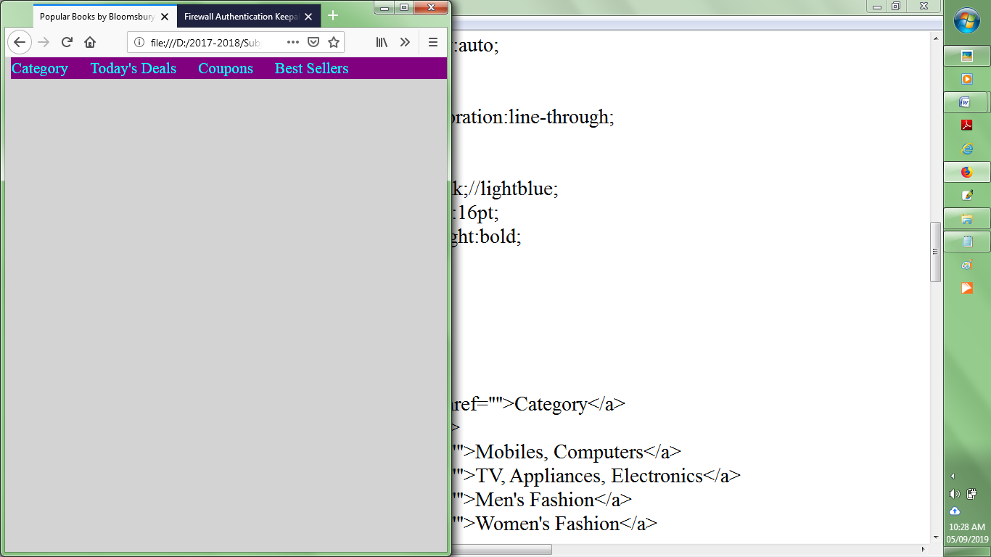

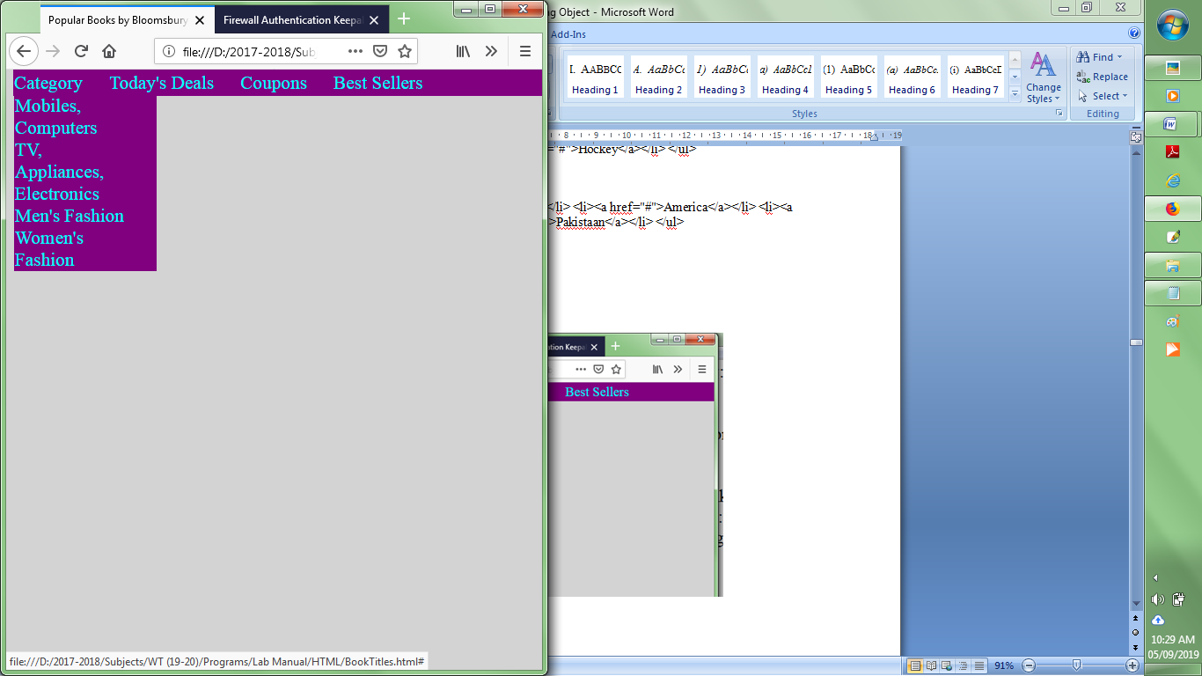

**Result:**

Thus a web page with menu layout has been designed using suitable CSS properties.

**Viva Questions**

1. How to sets all the border properties in one declaration?
2. Create a dropdown menu as given below

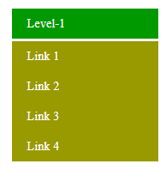

1. Create a dropdown menu that allows the user to choose an option from a list
2. Write a CSS property to display drop-down content at right side of the screen.

Example:

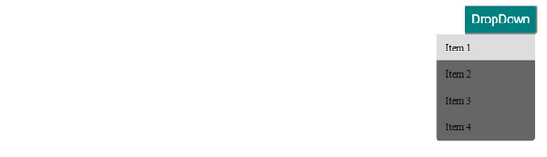

1. Set the color for unvisited links to "red" and the color of the visited links to "blue".
2. Update the CSS code given below to set the top and bottom paddings for <p> to "25px", and left and right paddings to "50px".

**<html>**

**<head>**

**<style>**

**p {**

**background-color: lightblue;**

**}**

**</style>**

**</head>**

**<body>**

**<h1>This is a Heading</h1>**

**<p>This is a paragraph.</p>**

**</body>**

**</html>**

1. **What happens if the list-style-type property is used on a non-list element like a paragraph?**
2. **How block elements can be centered with CSS?**
3. How do margin, border and padding fit together in the box model
4. Position the <h1> element relative to the browser window. 50px from the top, and 50px from the right.

<html>

<head>

<style>

h1 {

color: red;

................

}

</style>

</head>

<body>

<h1>This is a Heading</h1>

<p>This is a paragraph.</p>

<p>This is another paragraph.</p>

</body>

</html>

**Experiment 4:**

**DESIGN A WEB PAGE USING HTML5 PAGE STRUCTURE ELEMENTS**

**Aim:** To design a web page using HTML Page Structure Elements

**Description:**

**Page Structure Elements**

HTML5 introduces several new page-structure elements that meaningfully identify areas of the page as headers, footers, articles, navigation areas, asides, figures and more. The page structure elements provided by HTML5 are:

* header
* section
* article
* aside
* nav
* figure and figcaption
* meter
* mark
* wbr
* summary and details
* footer

1. **header Element**

The header element creates a header for this page that contains both text and graphics. The header element can be used multiple times on a page and can include HTML headings, navigation, images and logos and more. For an example, see the top of the front page of your favorite newspaper. time Element

The time element which does not need to be enclosed in a header, enables you to identify a date (as we do here), a time or both.

1. **nav Element**

The nav element groups navigation links. In this example, we used the heading Recent Publications and created a ul element with seven li elements that link to the corresponding web pages for each book.

1. **figure Element and figcaption Element**

The figure element describes a figure (such as an image, chart or table) in the document so that it could be moved to the side of the page or to another page. The figure element does not include any styling, but you can style the element using CSS. The figcaption element provides a caption for the image in the figure element.

1. **article Element**

The article element describes standalone content that could potentially be used or distributed elsewhere, such as a news article, forum post or blog entry. You can nest article elements. For example, you might have reader comments about a magazine nested as an article within the magazine article.

1. **summary Element and details Element**

The summary element (line 92) displays a right-pointing arrow next to a summary or caption when the document is rendered in a browser (Fig. 3.19). When clicked, the arrow points downward and reveals the content in the details element (lines 91–125).

1. **section Element**

The section element describes a section of a document, usually with a heading for each section—these elements can be nested. For example, you could have a section element for a book, then nested sections for each chapter name in the book. In this example, we broke the document into three sections—the first is Recent Publications (lines 21–43). The section element may also be nested in an article.

1. **aside Element**

The aside element describes content that’s related to the surrounding content (such as an article) but is somewhat separate from the flow of the text. For example, an aside in a news story might include some background history. A print advertisement might include an aside with product testimonials from users.

Structure of a Web Page with Page Structure Elements

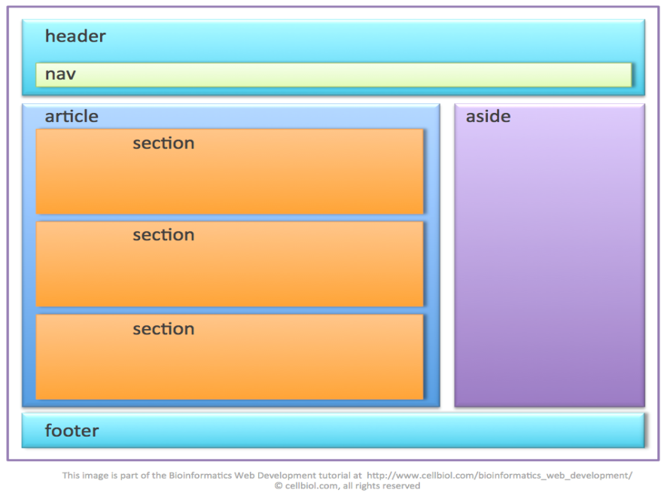

**Program:**

<html>

<head><title>Stylesheet and Menus</title>

<link rel="stylesheet" type="text/css" href="CSS1.css">

<style>

.ssmenu{

display: none;

position: absolute;

margin-left:170;

top:70;

z-index: 1;

width:167px;

}

#sccs:hover .ssmenu{

display:block;

background-color:lightgrey;

}

.ssmenu a:hover {

background-color:rgb(0,110,185);

}

#mainContent{

background-color:black;

opacity:.8

}

#content{

position:absolute;

background-color:black;

color:white;

font-family:cambria;

font-size:13pt;

text-align:justify;

top:250px;

left:190px;

width:1070px;

height:800px;

padding-left:15px;

padding-top:15px;

}

.hods_msg{

background-color:black;

color:yellow;

width:13%;

height:60%;

font-family:cambria;

font-size:13pt;

text-align:justify;

position:relative;

left:0;

top:200px;

opacity:.8;

}

figure{

position:relative;

margin:0;

top:5px;

padding-left:10px;

}

#events{

background-color:grey;

opacity:.7;

}

summary a{

color:white;

}

.event{

border:groove 2px grey;

width:330px;

height:260px;

float:left;

padding:0px;

margin:6px;

}

.eventPic{

position:relative;

width:300px;

height:200px;

}

.eventContent{

position:relative;

bottom:230px;

left:7px;

width:300px;

height:200px;

background-color:lightgrey;

color:brown;

}

footer h4{

position:absolute;

bottom:-465px;

text-align:center;

background-color:lightgrey;

width:100%;

height:20px;

}

#others{

position:absolute;

top:700px;

width:1050px;

height:100px;

background-color:rgb(242,234,181);//black;

}

h3{

background-color:rgb(242,234,181);

color:black;

opacity:.8;

}

</style>

</head>

<body>

<header id="header">

<img src="../Images/main_header1.jpg" width="100%" />

<nav class="main_menu">

<ul>

<li class="menus"><a href="kec_home.html">Home</a></li>

<li class="menus"><a href=" ">About KEC</a></li>

<li class="menus"><a href=" ">Schools</a>

<nav class="smenus">

<a href=" ">SBMS</a>

<a href=" ">SES</a>

<div id="sccs"><a href=" ">SCCS</a>

<nav class="ssmenu">

<a href=" ">CSE</a>

<a href=" ">IT</a>

<a href=" ">ECE</a>

</nav>

</div>

<a href=" ">S & H</a>

</nav>

</li>

<li class="menus"><a href=" ">Facilities</a>

<nav class="smenus">

<a href=" ">Class Rooms</a>

<a href=" ">Laboratories</a>

<a href=" ">Seminar Halls</a>

</nav>

</li>

<li class="menus"><a href=" ">R&D</a>

<nav class="smenus">

<a href=" ">Projects</a>

<a href=" ">Workshops</a>

<a href=" ">Seminars</a>

<a href=" ">Publications</a>

</nav>

</li>

<li class="menus"><a href=" ">Placement</a></li>

</ul>

</nav>

</header>

<aside id="sidenav">

<nav>

<a href=" ">Student Centric Activities</a>

<a href=" ">Students' Achievements</a>

<a href=" ">Kongu CRS</a>

<a href=" ">KEC Virtual Tour</a>

</nav>

</aside>

<article class="hods_msg">

<h3>HoD's Desk</h3>

<img src="../Images/rrr.png" width="120px" style="position:relative;margin- left:20px;"/>

<p>Message from HoD</p>

</article>

<article id="CSEA" style="position:absolute;top:840px;height:350px;left:40px;">

<img src="../Images/KEC_Transform.jpg" width="100px" style="position:relative;top:80px;"/>-

</article>

<div id="mainContent">

<article id="content">

<h3>Vision</h3>

<p>To be a centre of excellence for development and dissemination of knowledge in Electronics and Communication Engineering for the Nation and beyond.

</p>

<h3>Mission</h3>

<p>Department of Electronics and Communication Engineering is committed

<ul>

<li>To impart industry and research based quality education for developing value based Electronics and Communication engineers</li>

<li> To enrich the academic activities by continual improvement in the teaching learning process</li>

<li>To infuse confidence in the minds of students to develop as entrepreneurs</li>

<li>To develop expertise for consultancy activities by providing thrust for Industry Institute Interaction</li>

<li>To endeavor for constant up gradation of technical expertise for producing competent professionals to cater to the needs of the society and to meet the global challenges</li>

</ul>

</p>

<article id="events">

<h3>Events Scheduled</h3>

<section class="event" style="font-color:yellow;font-family:callibri;">

<details style="font-size:12pt;">

<summary><a href="http://keci2c2sw.kongu.edu/ " target="blank"><mark>I2C2SW 2018</mark></a>

<figure>

<img class="eventPic" src="../Images/digital_world1.jpg"/>

<figcaption style="text-align:center;font- size:13pt;">I2C2SW</figcaption>

</figure>

</summary>

<p class="eventContent" style="font-color:yellow;">

The Conference focuses on the core technological developments in the emerging fields like Intelligent Computing, Communications and Control. These technologies have the potential to attract many intellectuals from India and abroad as a congregation to deliberate on the above themes and applications.

</p>

</details>

</section>

<section class="event">

<details style="font-size:12pt;">

<summary><a href="eeebrns.pdf">DAE-BRNS Sponsored National Seminar</a>

<figure>

<img class="eventPic" src="../Images/CollaborativeLearning.jpg"/>

<figcaption style="text-align:center;font-size:13pt;">

National Seminar</figcaption>

</figure>

</summary>

<p class="eventContent">

In the present scenario, green technologies are playing significant role in changing the course of nation’s economic growth towards sustainability and providing an alternative socio-economic model that will enable present and future generations to live in a clean and healthy environment, in harmony with nature.

</p>

<p>

<dl>

<dt>SCHEDULED DATES:</dt>

<dd>Last Date for receipt of Applications: 16.07.2018<br/>

Intimation of Participants : 17.07.2018<br/>

Confirmation of Participants : 18.07.2018<br/></dd>

</dl>

</p>

</details></section>

<section class="event"><details style="font-size:12pt;">

<summary><a href="eeebrns.pdf">AICTE Sponsored National Seminar</a>

<figure>

<img class="eventPic" src="../Images/spectrum1.jpg"/>

<figcaption style="text-align:center;font-size:13pt;">

National Workshop</figcaption>

</figure>

</summary>

<p class="eventContent">

In the present scenario, green technologies are playing significant role in changing the course of nation’s economic growth towards sustainability and providing an alternative socio-economic model that will enable present and future generations to live in a clean and healthy environment, in harmony with nature.

</p>

</details></section>

</article>

<aside id="others">

<h3 style="text-align:center;color:black;opacity:.8;">Other Events</h3>

</aside>

</article>

</div>

<footer><h4>Website maintainted by KEC Web Group</h4></footer>

</boby>

</html>

**Output:**







**Result:**

Thus a web page has been designed using HTML Page Structure Elements.

**Viva Questions:**

**1 & 2. Identify the suitable page structure elements to design the content that is pointed in the following web page**

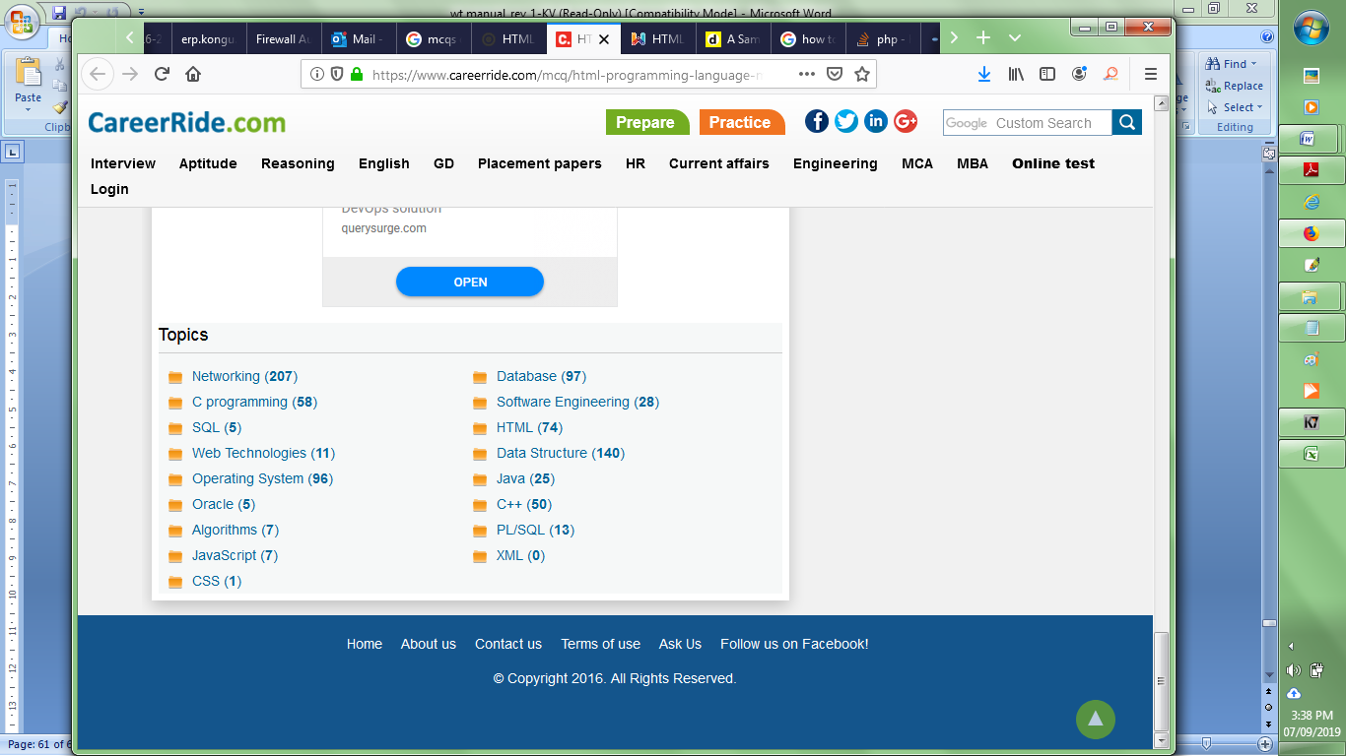

3. Design the content that is pointed in the web page shown below using appropriate page structure element and HTML5 elements

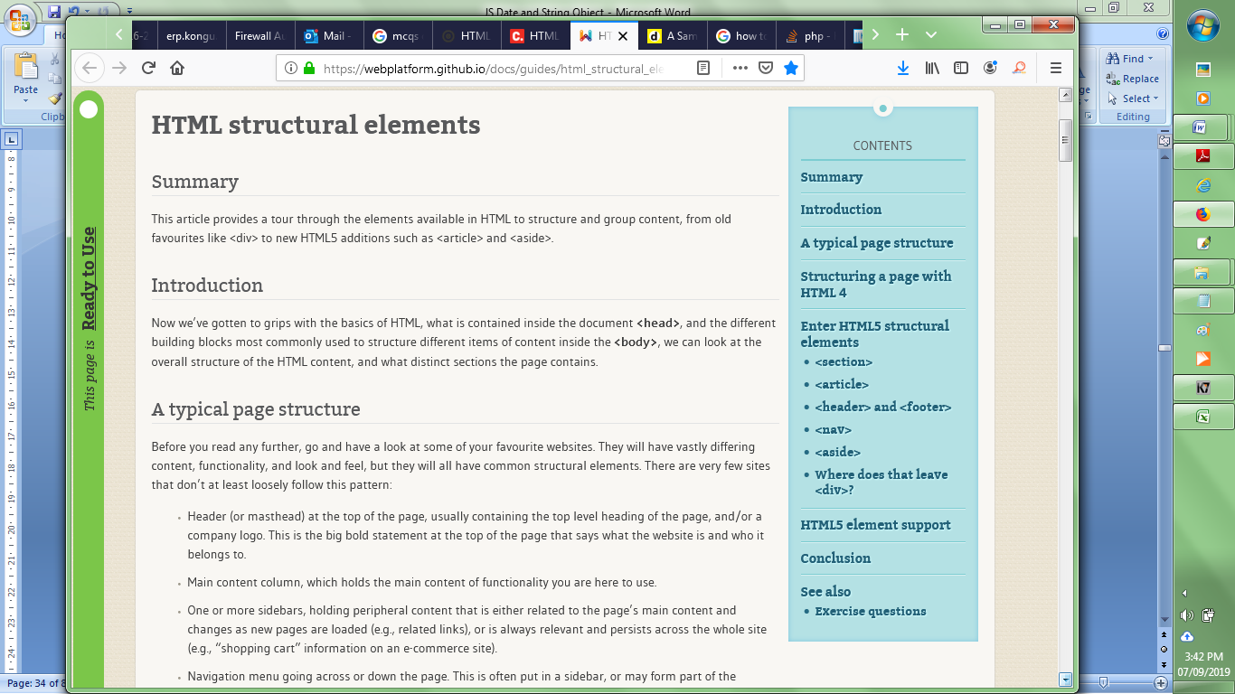

4. Make use of ‘figure’ and ‘figcaption’ elements to display the photograph of any event along with the event’s title on a web page.

5. Display the details of the above event using ‘summary’ and ‘details’ tags.

**Experiment 5:**

**DESIGN A REGISTRATION FORM AND VALIDATE THE FORM DATA USING JAVASCRIPT**

**Aim:** To design a registration page to create email-id and validate the information in the web page using JavaScript

**Description:**

|  |  |
| --- | --- |
| **Tag** | **Description** |
| **<form>** | The <form> tag is used to create an HTML form for user input.  The <form> element can contain one or more of the following form elements:   * [<input>](https://www.w3schools.com/tags/tag_input.asp), [<textarea>](https://www.w3schools.com/tags/tag_textarea.asp), [<button>](https://www.w3schools.com/tags/tag_button.asp), [<select>](https://www.w3schools.com/tags/tag_select.asp), [<option>](https://www.w3schools.com/tags/tag_option.asp), [<optgroup>](https://www.w3schools.com/tags/tag_optgroup.asp), [<fieldset>](https://www.w3schools.com/tags/tag_fieldset.asp), [<label>](https://www.w3schools.com/tags/tag_label.asp), [<output>](https://www.w3schools.com/tags/tag_output.asp) |
| **<input>** | The <input> tag specifies an input field where the user can enter data.   |  |  |  | | --- | --- | --- | | **Attribute** | **Value** | **Description** | | [type](https://www.w3schools.com/tags/att_input_type.asp) | Button, checkbox, color, date  datetime-local, email,  file, hidden, image, month, number,  password, radio, range  reset, search submit, tel, text, time, url, week | Specifies the type <input> element to display | | [align](https://www.w3schools.com/tags/att_input_align.asp) | left, right, top, middle, bottom | Specifies the alignment of an image input (only for type="image") | | [autocomplete](https://www.w3schools.com/tags/att_input_autocomplete.asp) | on, off | Specifies whether an <input> element should have autocomplete enabled | | [autofocus](https://www.w3schools.com/tags/att_input_autofocus.asp) | autofocus | Specifies that an <input> element should automatically get focus when the page loads | | [height](https://www.w3schools.com/tags/att_input_height.asp) | pixels | Specifies the height of an <input> element (only for type="image") | | [max](https://www.w3schools.com/tags/att_input_max.asp) | number date | Specifies the maximum value for an <input> element | | [maxlength](https://www.w3schools.com/tags/att_input_maxlength.asp) | number | Specifies the maximum number of characters allowed in an <input> element | | [min](https://www.w3schools.com/tags/att_input_min.asp) | number date | Specifies a minimum value for an <input> element | | [multiple](https://www.w3schools.com/tags/att_input_multiple.asp) | multiple | Specifies that a user can enter more than one value in an <input> element | | [name](https://www.w3schools.com/tags/att_input_name.asp) | Text | Specifies the name of an <input> element | | [placeholder](https://www.w3schools.com/tags/att_input_placeholder.asp) | Text | Specifies a short hint that describes the expected value of an <input> element | | [required](https://www.w3schools.com/tags/att_input_required.asp) | required | Specifies that an input field must be filled out before submitting the form | | [size](https://www.w3schools.com/tags/att_input_size.asp) | number | Specifies the width, in characters, of an <input> element | | [value](https://www.w3schools.com/tags/att_input_value.asp) | Text | Specifies the value of an <input> element | | [width](https://www.w3schools.com/tags/att_input_width.asp) | pixels | Specifies the width of an <input> element (only for type="image") | |
| [**<select>**](https://www.w3schools.com/tags/tag_select.asp)  [**<option>**](https://www.w3schools.com/tags/tag_option.asp) | The <select> element is used to create a drop-down list.  The <option> tags inside the <select> element define the available options in the list. |
| [**<textarea>**](https://www.w3schools.com/tags/tag_textarea.asp) | The <textarea> tag defines a multi-line text input control.   |  |  |  | | --- | --- | --- | | **Attribute** | **Value** | **Description** | | cols | number | Specifies the visible width of a text area | | [rows](https://www.w3schools.com/tags/att_textarea_rows.asp) | number | Specifies the visible height of a text area | |
| [**<button>**](https://www.w3schools.com/tags/tag_button.asp) | The <button> tag defines a clickable button.   |  |  |  | | --- | --- | --- | | **Attribute** | **Value** | **Description** | | [type](https://www.w3schools.com/tags/att_button_type.asp) | button reset submit | Specifies the type of button | | [value](https://www.w3schools.com/tags/att_button_value.asp) | text | Specifies an initial value for the button | |

Forms are used in webpages for the user to enter their required details that are further sent to the server for processing. The data entered into a form needs to be in the right format and certain fields need to be filled in order to effectively use the submitted form. **JavaScript**is used to validate the form.

**Program:**

<html>

<head><title>Email and Password Validation using JavaScript String Object</title>

<style>

div{

width:500px;

height:auto;

background-color:dodgerblue;

opacity:.9;

position:fixed;top:50px;left:450px;

text-align:left;

border-radius:50px;

}

form{

margin-left:50px;

}

input{

border-radius:50px;

height:30px;width:200px;

}

label{

color:brown;

font-size:15pt;

}

</style>

</head>

<body style="background-image:url('../Images/bg.png');">

<div>

<h1 style="text-align:center;color:yellow;">Sign Up</h1>

<form>

<label>Emial-ID</label>

<input type="text" id="mail1" onblur="validate()" style="margin- left:100px;"/><br/><br/>

<label> Password</label>

<input type="password" id="pass" onblur="del()" style="margin- left:100px;"/><br/><br/>

<label> Re-type Password</label>

<input type="password" id="cpass" onblur="cmp()" style="margin- left:40px;"/><br/><br/>

<br/><input type="submit" value="Sign-Up"/>

</form>

</div>

<script>

var email,pass1,pass2,el,pl,em;

function validate()

{

email=document.getElementById("mail1");

em=email.value;

if(em=="")

{

window.alert("Please enter your email ID");

email.focus();

}

//Email Validation

else if(em.indexOf('@')<=3)

{

alert("Enter a valid Email ID");

}

else{

alert(em);

var x=em.split("@");

var dotPos=x[1].indexOf('.');

var xl=x[0].length;

xl=xl+1;

var y=x[1].split(".");

if(dotPos==xl)

alert("Enter the email in correct format");

else if(y[1]!="com" || y[1]!="edu" || y[1]!="co" || y[1]!="ac")

alert("Enter the email in correct format");

else

window.location.href="personalInfo.html";

}

}

function del()

{

//Password Validation

pass1=document.getElementById("pass");

pl=pass1.value.length;

if( pass1.value=="")

{

alert("Please fill the password field")

pass1.focus();

}

else{

if(pl<6)

alert("Weak Password");

else if(pl>10)

alert("Strong Password");

else

alert("Frame strong password to secure it");

}

}

function cmp()

{

pass1=document.getElementById("pass").value;

pass2=document.getElementById("cpass").value;

if(pass1!==pass2)

alert("Confirm password does not match with password field");

}

</script>

</body>

</html>

**Output:**

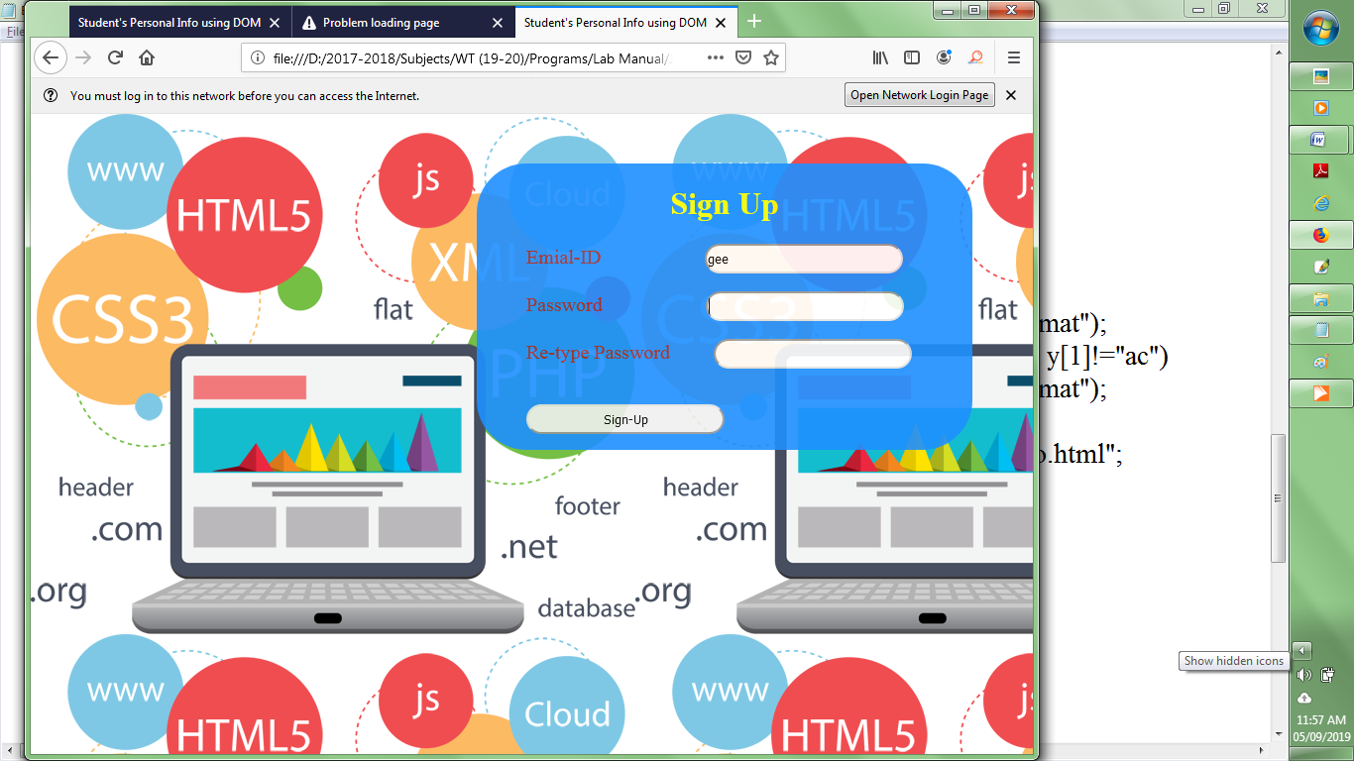

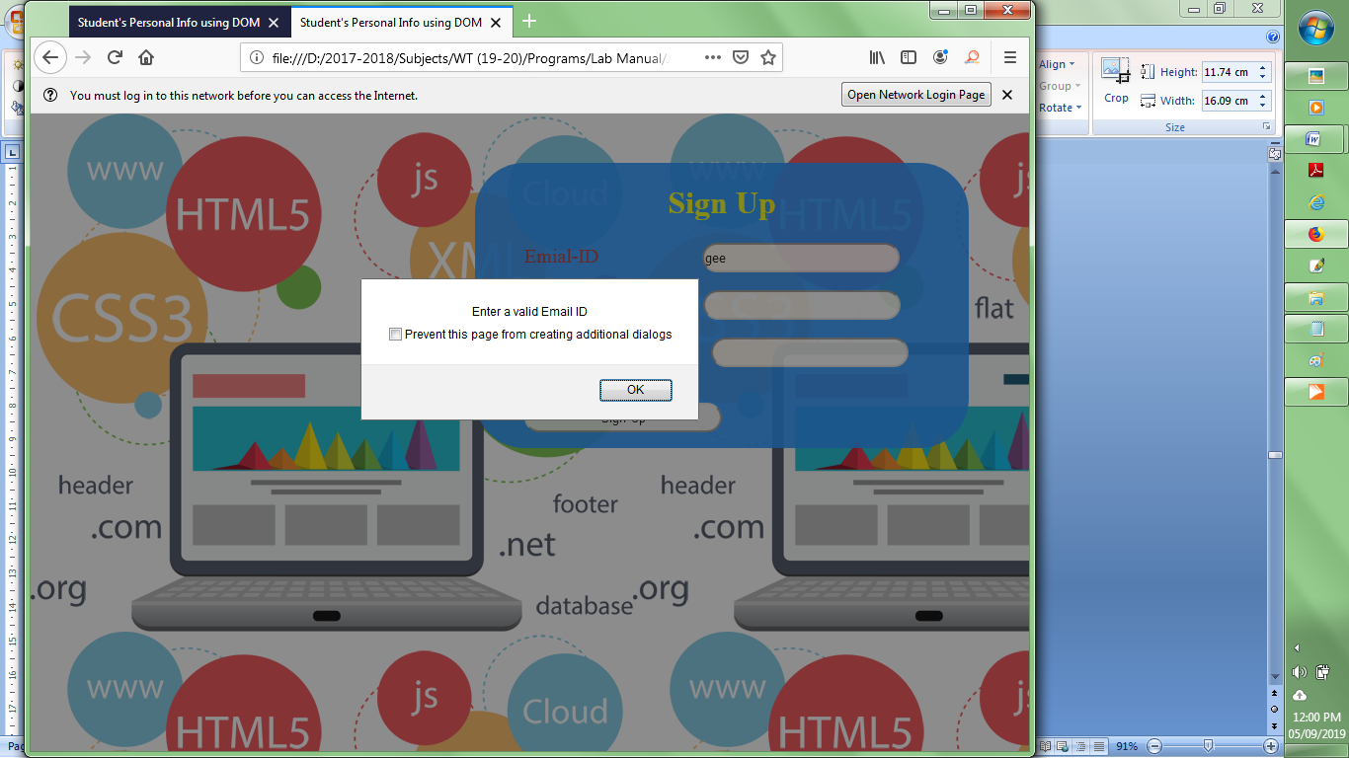

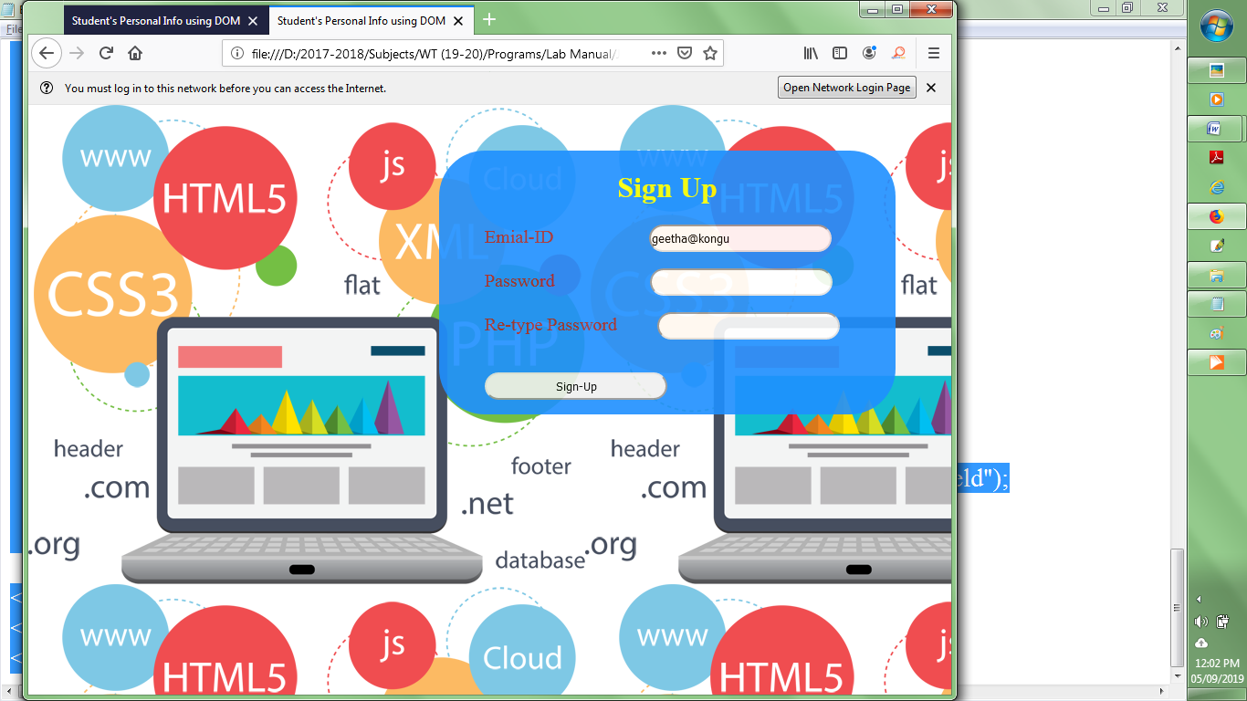

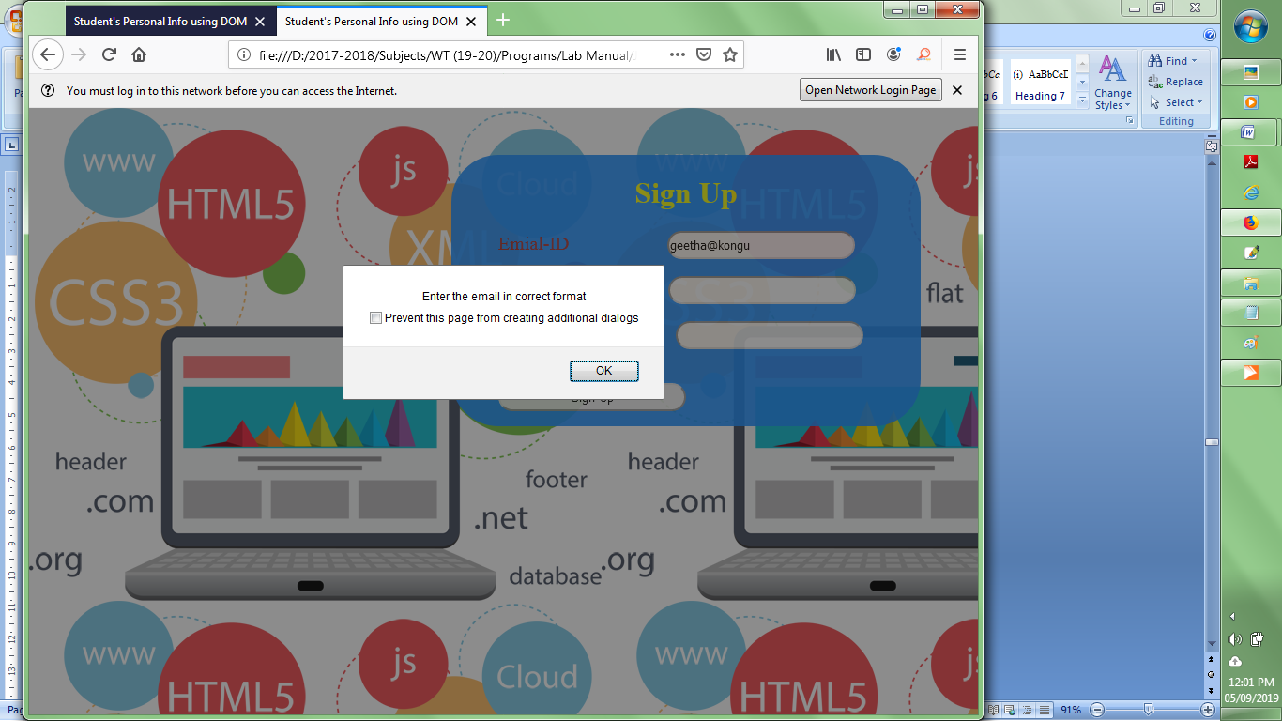

**Result:**

Thus a registration page has been designed and the information in the form has been validated using JavaScript string objects

**Experiment 6:**

**DEVELOP DYNAMIC WEB PAGES USING DOM OBJECTS AND COLLECTIONS**

**Aim:** To design web pages using JavaScript Objects and Collections

**Description:**

**DOM Structure of a HTML document**

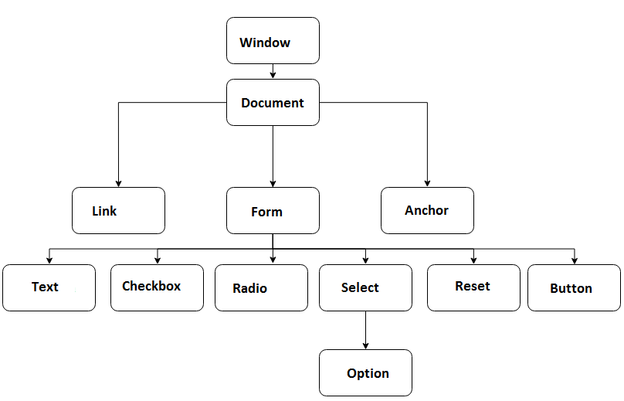

**Document Object Model (DOM)**

The HTML DOM is a standard way of getting, changing, adding, or removing HTML elements. DOM is a platform and language-neutral interface that allows programs and scripts to dynamically access and update the content, structure, and style of a HTML document.

* HTML DOM methods are actions that you can perform on HTML Elements
* HTML DOM properties are values of HTML Elements that you can set or change.
* In DOM, all HTML elements are defined as objects.

**Refering the HTML Elements**

* document.getElementById(id) - Refer an element by element id
* document.getElementsByTagName(name) - Refer elements by tag name
* document.getElementsByClassName(name) - Refer elements by class name
* document.getElementsByName(name) - Refer elements by name

**Changing the Content and Appearance of HTML Elements**

* element.innerHTML = new html content 🡪 Change the inner HTML of an element
* element.attribute = new value (or) element.setAttribute(attribute, value)
  + Change the attribute value of an HTML element
* element.style.property = new style 🡪 Change the style of an HTML element

**Create, add and Delete Elements**

* document.createElement(element) 🡪 Create an HTML element
* document.createAttribute() 🡪 Creates an attribute node
* document.createComment() 🡪 Creates a Comment node with the specified text
* document.createTextNode() 🡪 Creates a Text node
* document.removeChild(element) 🡪 Remove an HTML element
* document.appendChild(element) 🡪 Add an HTML element
* document.replaceChild(new, old) 🡪 Replace an HTML element
* document.write(text) 🡪 Write into the HTML output stream

**DOM Collections**

* images
* links
* forms
* anchors

The collection’s length property specifies the number of items in the collection.

* document.links.length 🡪 specifies the number of links
* document.images.length 🡪 specifies the number of images
* document.forms.length 🡪 specifies the number of forms
* document.getElementById("myform").elements.length 🡪 specifies the number of form elements in "myform"

**Program:**

1. **Fee Payment using Date Object**

<html>

<head><title>Fee Payment using Date Object</title>

<style>

body{

background-image:url("../Images/bg.png");

height:100%;

width:100%;

}

#head1{

text-align:center;

background-color:black;

color:white;

position:relative;

top:-25;

}

#content{

width:400px;

height:auto;

background-color:DarkOrange ;//rgb(48, 70, 232);

opacity:.9;

position:relative;

top:0;left:450px;

text-align:center;

overflow:auto;

}

</style>

</head>

<body>

<header>

<img src="../Images/main_header1.jpg" style="height:150px;width:100%;"/>

<h1 id="head1">DEPARTMENT OF CSE</h1>

</header>

<div id="content">

<h1>Onlie Fee Payment</h1>

<form>

<p style="font-size:15pt;font-weight:bold;">Name&nbsp;&nbsp;&nbsp;

<input type="text" id="uname" value=" "/><br/><br/>

Roll No.&nbsp;&nbsp;&nbsp;

<input type="text" id="roll" value=" "/><br/><br/>

Year of Study&nbsp;&nbsp;

<select id="yr">

<option>Select</option>

<option value="I">I</option>

<option value="II">II</option>

<option value="III">III</option>

<option value="IV">IV</option>

</select><br/><br/>

Department&nbsp;&nbsp;

<select id="dept">

<option>Select</option>

<option value="civil">CIVIL</option>

<option value="mechanical">MECHANICAL</option>

<option value="automobile">AUTOMOBILE</option>

<option value="ece">ECE</option>

<option value="eie">EIE</option>

<option value="eee">EEE</option>

<option value="cse">CSE</option>

<option value="it">IT</option>

</select><br/><br/>

<input type="button" onclick="PayFee()" value="Pay"/>

</p>

</form>

<h3 style="font-weight:bold;background-color:#350000; color:LimeGreen; width:150px;margin-left:130px;" id="details">Your Details: </h3>

<h3 style="font-weight:bold;" id="status"></h3>

</div>

<script>

var stName,stRoll,stDept,stYear;

var h,st;

function PayFee()

{

stName=document.getElementById("uname").value;

stRoll=document.getElementById("roll").value;

stDept=document.getElementById("dept").value;

stYear=document.getElementById("yr").value;

st=document.getElementById("status");

h=document.getElementById("details");

var dt2=new Date();

var current=dt2.getDate();

var dt1=new Date(2019,8,6);

//Checking the due date

if(currentDate<=dt1.getDate() && currentMonth<=dt1.getMonth())

{

alert("Can Pay");

stName=stName.toUpperCase();

stRoll=stRoll.toUpperCase();

stDept=stDept.toUpperCase();

h.innerHTML+="<br/>"+stName+"<br/>"+stRoll+"<br/>"+stDept+"<br/>"+stYear;

st.style.color="green";

st.innerHTML="Your Payment is Successfull";

}

else

{

st.style.color="red";

st.innerHTML="Can't Pay after due date. Contact Office ";

}

}

</script>

</body>

</html>

**Output:**

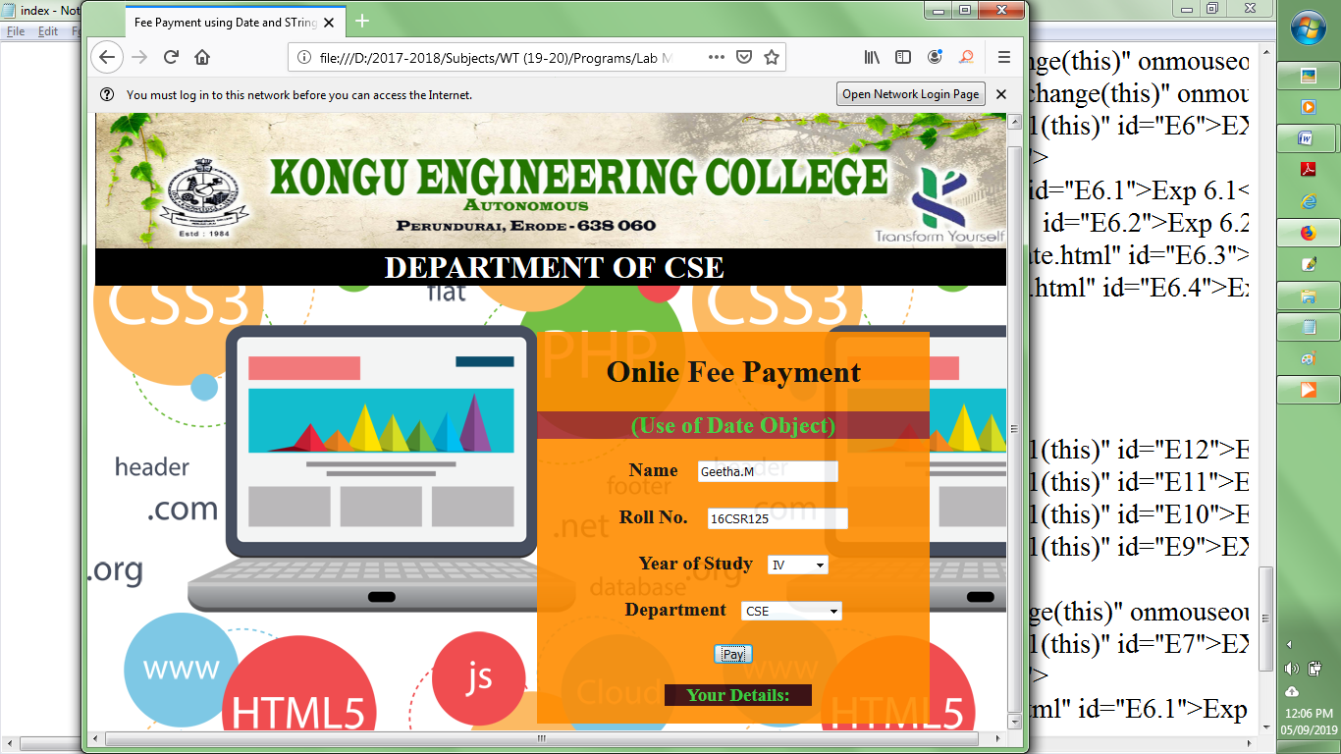

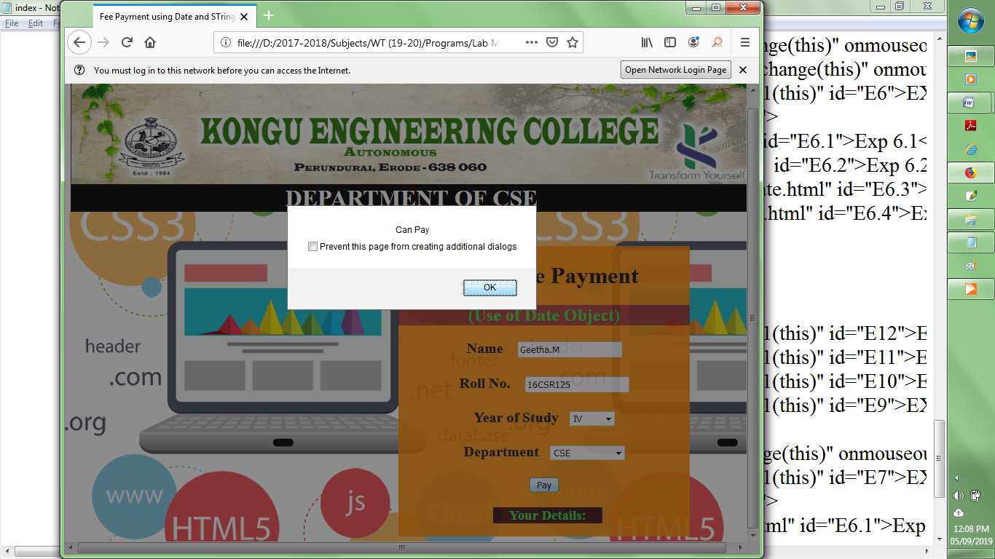

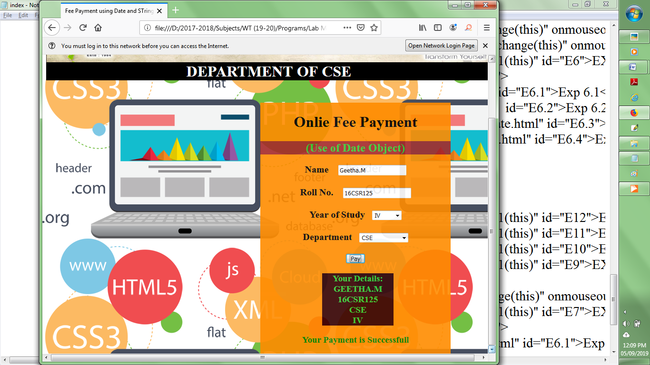

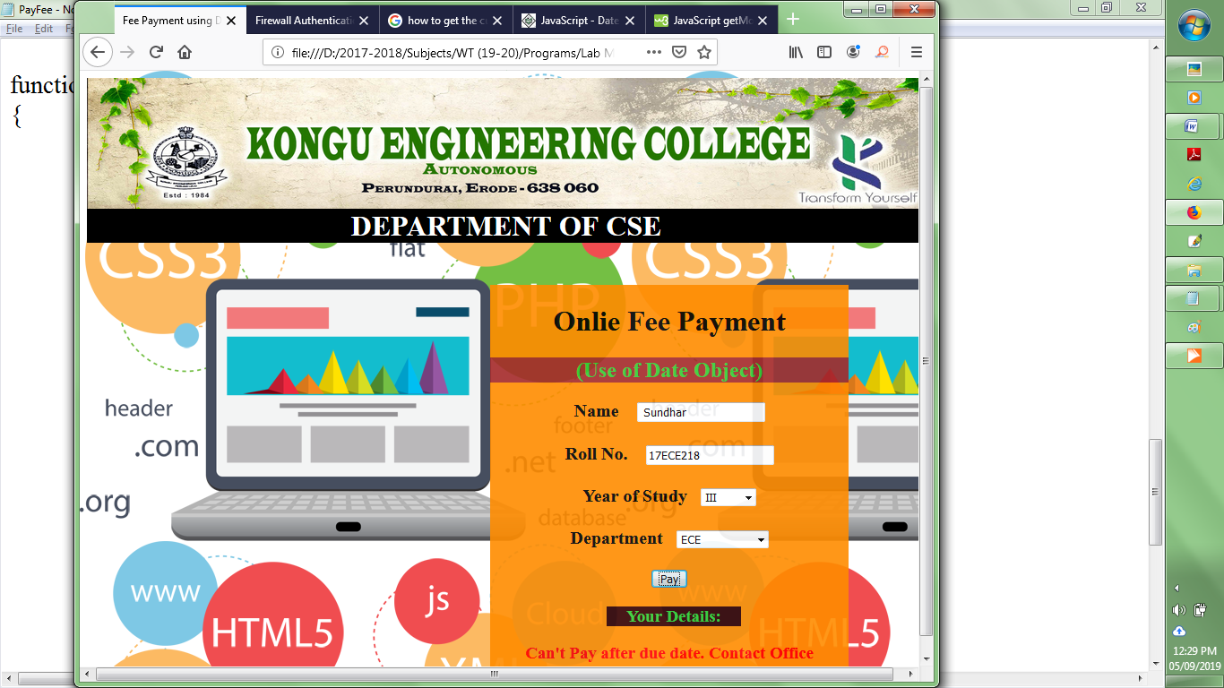

1. **Language Translation: English to PigLatin**

<html>

<head><title>Language Translation</title>

<style>

body{

background-image:url("../Images/bg.png");

background-repeat:repeat;

}

h2{

color:pink;

background-color:green;

width:300px;

font-size:20pt;

text-decoration:underline;

}

div{

background-color:limegreen;

width:900px;

height:auto;

position:fixed;

top:0;

}

</style>

</head>

<body>

<div>

<h1 style="text-align:center;color:gold;">Language Translation: English - PigLatin</h1>

<h2>Paragraph in English: </h2>

<p id="sen" style="color:purple;font-size:20pt;font-weight:bold;text-align:justify;background- color:gold;width:800px;">

Kongu Engineering College, one of the foremost multi professional research-led Institutions is internationally a recognized leader in professional and career-oriented education. It provides an integral, inter-disciplinary education - a unique intersection between theory and practice, passion and reason. </p>

<h2>Paragraph in PigLatin : </h2>

<p id="res" style="color:gold;background-color:purple;font-weight:bold;font-size:20pt;text- align:justify;width:800px;"></p>

<form>

<input type="button" id="bt" value="Translate" style="background- color:brown;color:white;font-size:20pt;width:160px;height:60px;" onclick="Token()"/>

</form>

</div>

<script>

var text=document.getElementById("sen").innerHTML;

var pigLatin=[];

var text1=" ";

function Token()

{

var token=text.split(" ");

var len=token.length;

var s,tlen;

var sub,ans;

ans=document.getElementById("res");

for(var k=0;k<len;k++)

{

s=token[k].charAt(0);

tlen=token[k].length;

sub=token[k].slice(1,tlen);

pigLatin[k]=sub+s+"ay";

text1+=pigLatin[k]+" ";

}

ans.innerHTML=text1;

}

</script>

</body>

</html>

**Output:**

Before Translation

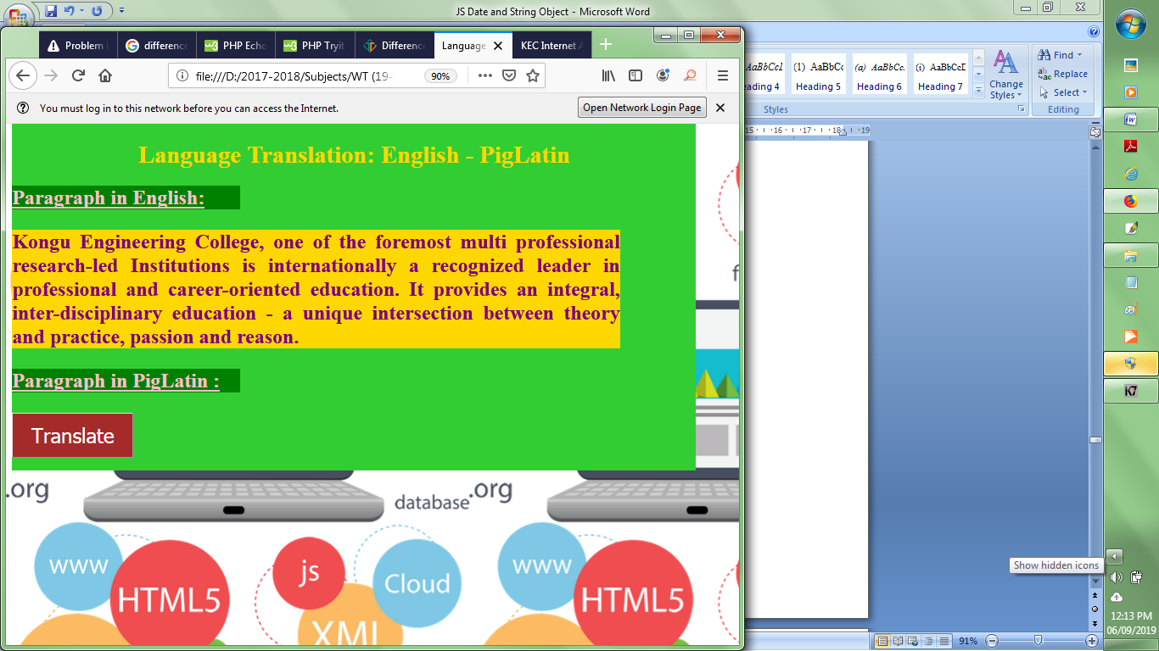

After Translation

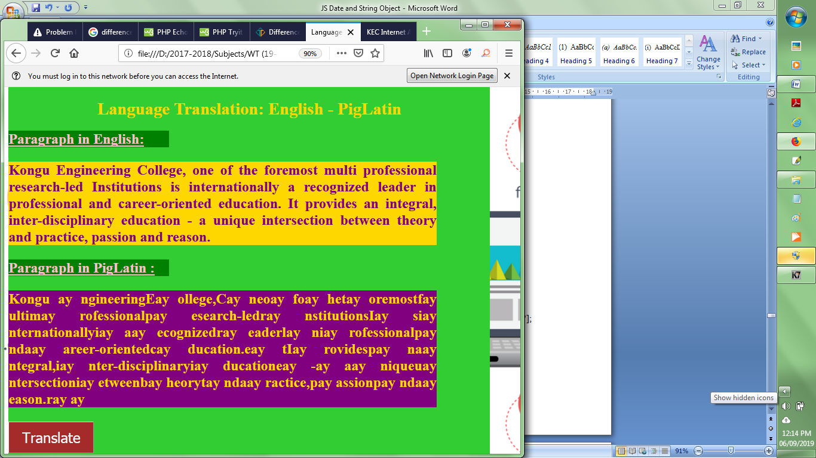

**iii) Simple Animations using Document Object Model**

1. ***Image Animation***

<html>

<head></head>

<body id="doc1" >

<h2 style="color:red;"> Simple Animation using Document Object Model</h2>

<img id="pic1" src="Banner.jpg" width="80" height="120"/>

<script type="text/javascript">

var img;

var id,x,y;

img=document.getElementById("pic1");

x=img.width;

y=img.height;

function animate()

{

id = setInterval(enlarge, 10);

}

function enlarge()

{

if(y<=375)

{

x+=1;

y+=1;

img.setAttribute("width",x+"px");

img.setAttribute("height",y+"px");

}

else

{

clearInterval(id);

}

}

img.addEventListener("click",animate,false);

</script>

</body>

</html>

**Output:**

Before Animation

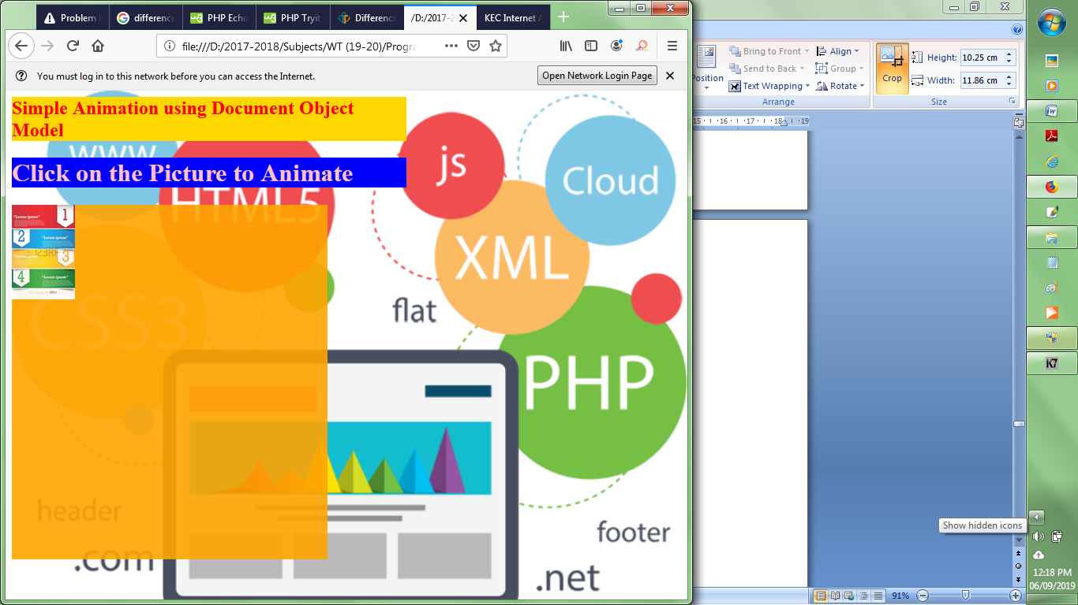

During Animation

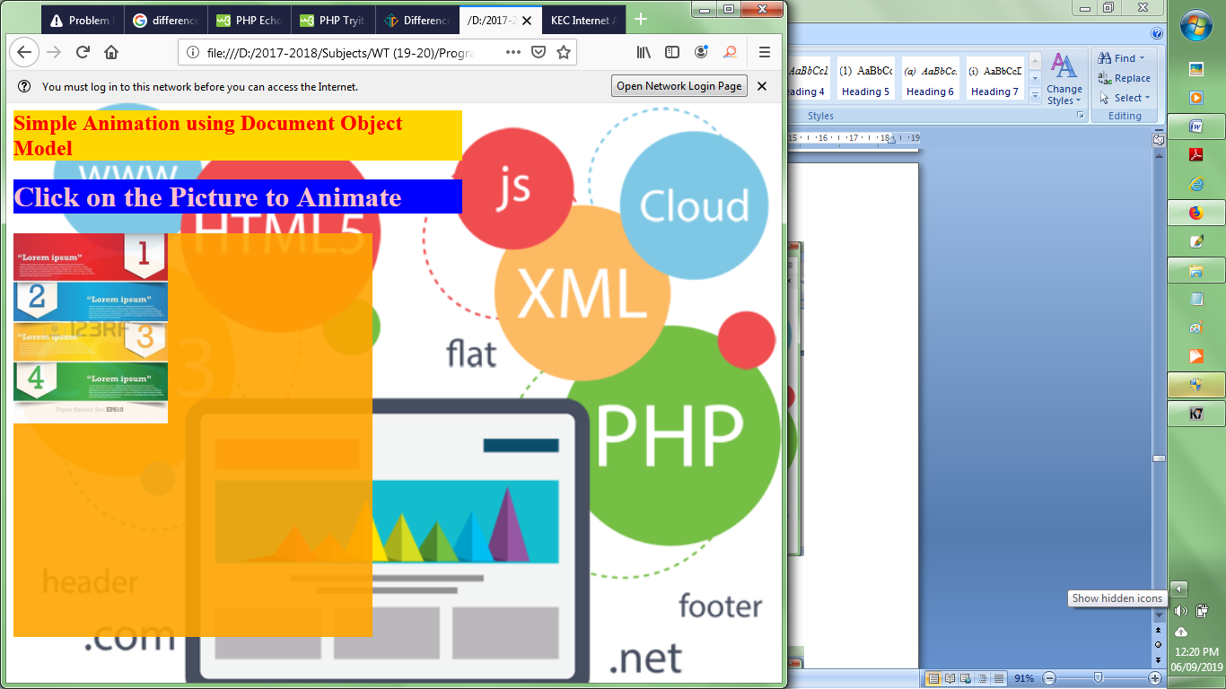

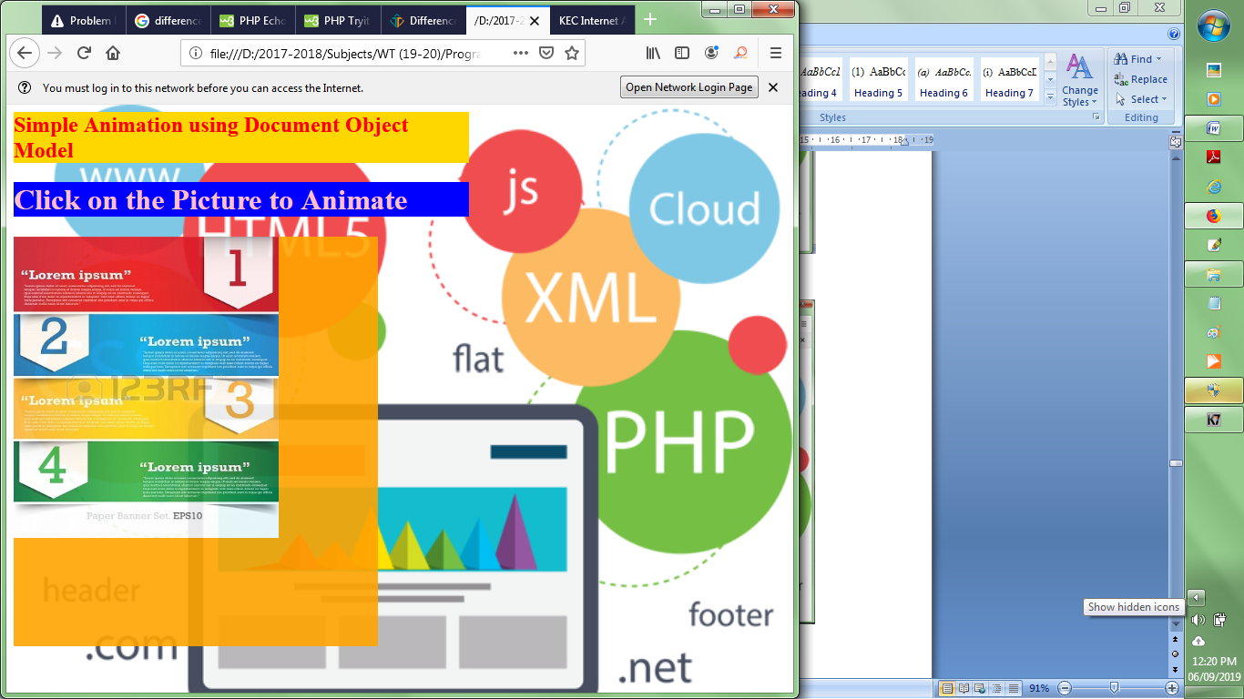

1. ***Color Animation***

<html>

<head></head>

<body id="doc1">

<h1 style="text-align:center;color:green;" id="kec" onclick="change()">

Kongu Engineering College</h1>

<h1 align="center" color="green" id="cse"> Deparment of CSE</h1>

<script type="text/javascript">

var color1=["red","pink","purple","orange","yellow","green","blue","violet"];

var color2=["violet","blue","yellow","brown","orange","lightblue","pink","red"];

var l=color1.length;

var id,i,cl=5;

var bg=document.getElementById("doc1");

var head1=document.getElementById("kec");

var head2=document.getElementById("cse");

var size=40;

function change()

{

i=0;

id=setInterval(animate,1000);

}

function animate()

{

if(i<l)

{

size+=2;

bg.style.backgroundColor=color1[i];

head1.style.backgroundColor=color2[i];

head1.style.fontSize=size+'px';

head2.style.color=color2[i];

i++;

}

else

{

clearInterval(id);

}

}

</script>

</body>

</html>

**Output:**

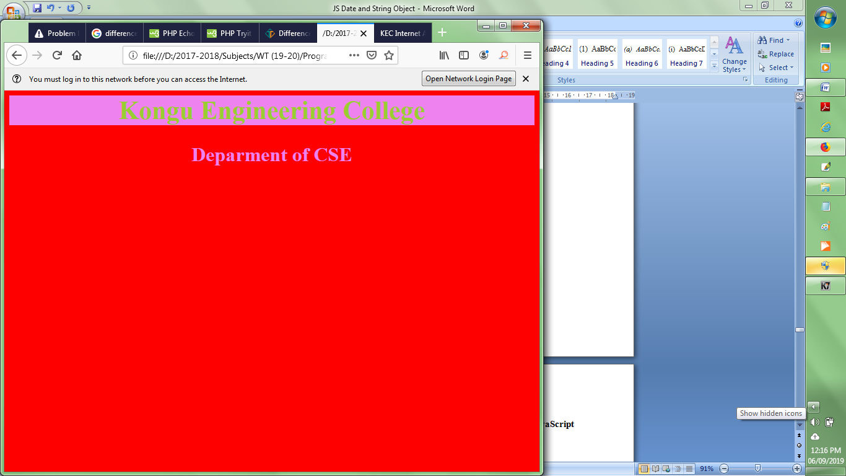

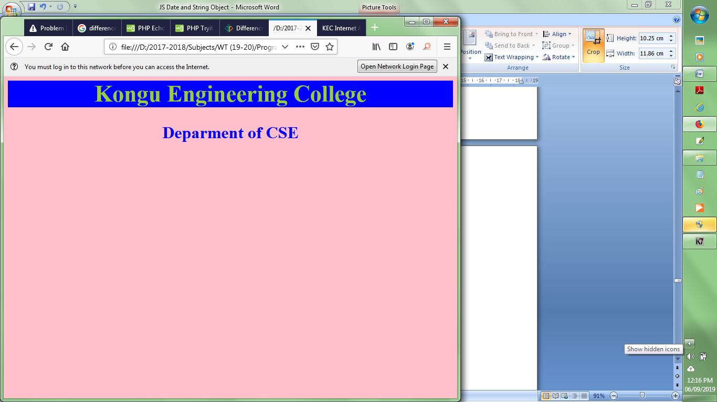

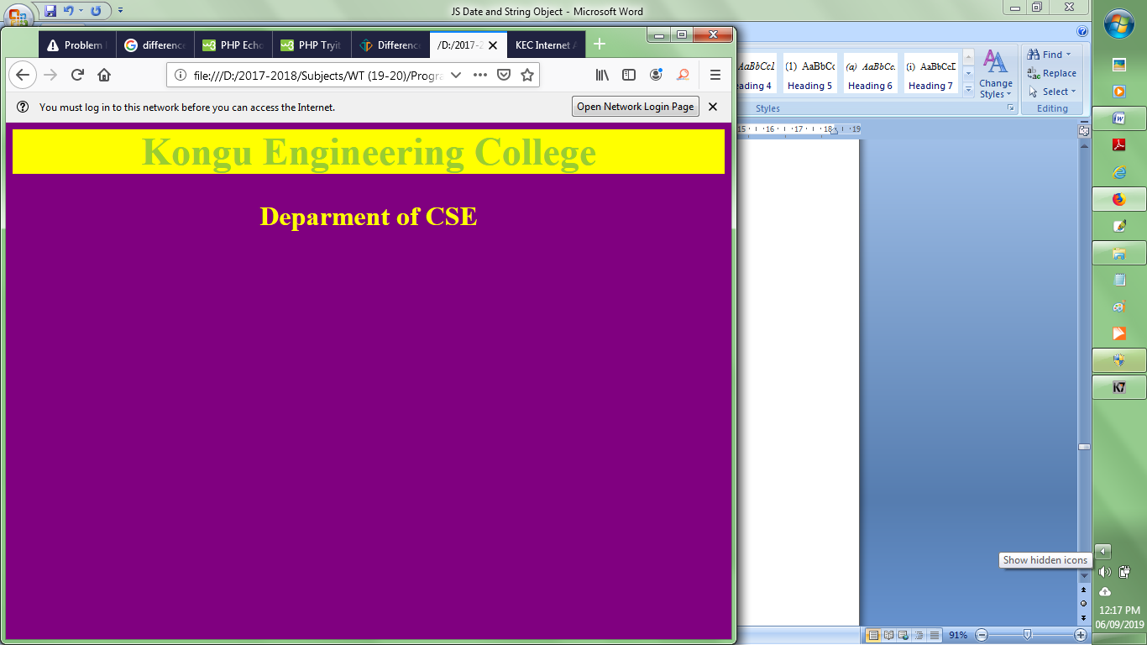

***iv) DOM Collections***

**Program:**

<html>

<head><title>DOM Collections</title>

<style>

#mEvents{

display:flex;

}

.back {

width: 300px;

height: 260px;

position: absolute;

top: 300px;

left: 0px;

background-color:green;

}

.flipper {

position: relative;

width:100%;

}

.front {

width: 300px;

height: 250px;

position: fixed;

top:0px;

display:inline;

padding:10px;

background-color:rgb(191, 255, 0);

}

.front img{

// position:relative;

width:100%;

height:200px;

}

.back p{

text-align:justify;

color:rgb(191, 255, 0);

padding:20px;

}

.front h3{

text-align:center;

}

</style>

</head>

<body>

<div id="mEvents" onclick="collect()">

<div class="flipper">

<div class="front">

<!-- front content -->

<h3>Event 1</h3>

<img src="../Images/flipImg1.jpg"/>

</div>

<div class="back">

<!-- back content -->

<p>

CSS animations are a lot of fun; the beauty of them is that through many simple properties, you can create anything from an elegant fade in to a WTF-Pixar-would-be-proud effect. One CSS effect somewhere in between is the CSS flip effect, whereby there's content on both the front and back of a given container. This tutorial will show you show to create that effect in as simple a manner as possible.

</p>

</div>

</div>

<div class="flipper">

<div class="front">

<!-- front content -->

<h3>Event 2</h3>

<img src="../Images/flipImg2.gif"/>

</div>

<div class="back">

<!-- back content -->

<p>

Quick note: this is not the first tutorial about this effect, but I've found the others over-complicated. Many other tutorials add additional styles to code samples which then require the reader to decipher which are needed and which aren't. This tutorial avoids that issue, providing you only the necessary styles; you can pretty up each side of the flip any way you'd like.

</p>

</div>

</div>

<div class="flipper">

<div class="front">

<!-- front content -->

<h3>Event 3</h3>

<img src="../Images/flipImg3.jpg"/>

</div>

<div class="back">

<!-- back content -->

<p>

CSS animations are a lot of fun; the beauty of them is that through many simple properties, you can create anything from an elegant fade in to a WTF-Pixar-would-be-proud effect. One CSS effect somewhere in between is the CSS flip effect, whereby there's content on both the front and back of a given container. This tutorial will show you show to create that effect in as simple a manner as possible.

</p>

</div>

</div>

<div class="flipper">

<div class="front">

<!-- front content -->

<h3>Event 4</h3>

<img src="../Images/flipImg4.jpg"/>

</div>

<div class="back">

<!-- back content -->

<p>

Quick note: this is not the first tutorial about this effect, but I've found the others over-complicated. Many other tutorials add additional styles to code samples which then require the reader to decipher which are needed and which aren't. This tutorial avoids that issue, providing you only the necessary styles; you can pretty up each side of the flip any way you'd like.

</p>

</div>

</div>

</div>

<!--Flip content url - https://davidwalsh.name/css-flip-->

<script>

function collect()

{

var pics=document.images;

var para=document.getElementsByClassName("back");

for(var i=0;i<pics.length;i++)

{

pics[i].setAttribute("style","border:6px solid red");

}

for(var j=0;j<para.length;j++)

{

para[j].setAttribute("style","border-radius:50px");

}

}

</script>

</body>

</html>

**Output:**

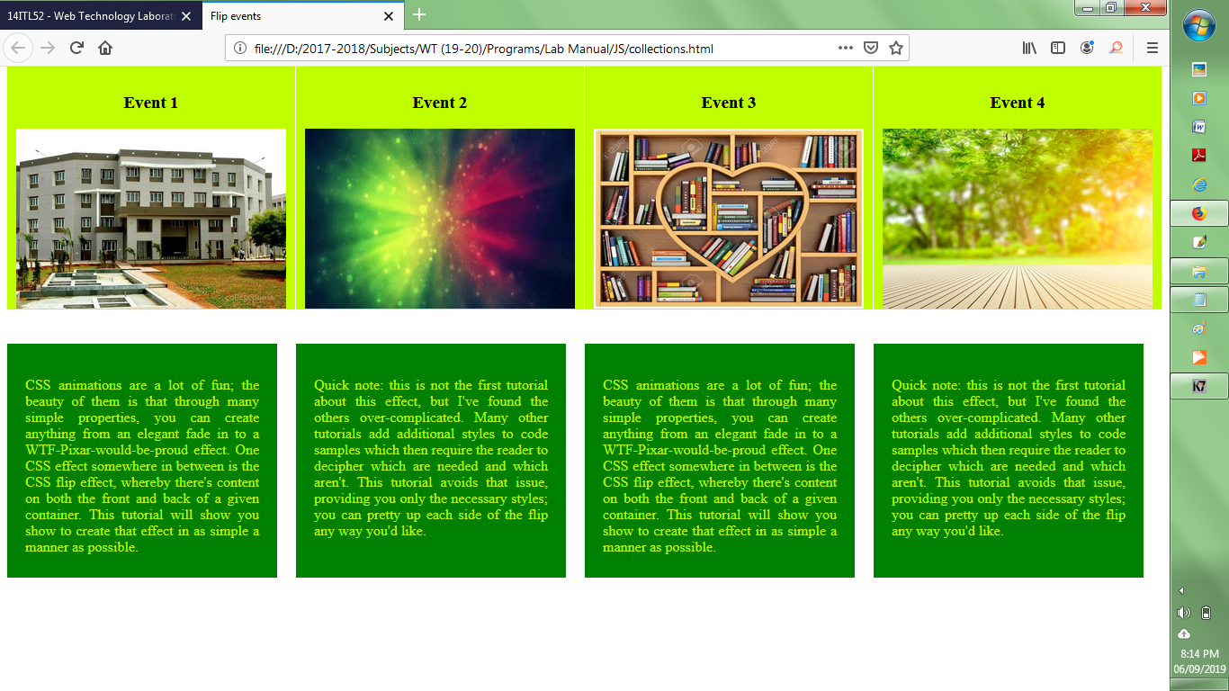

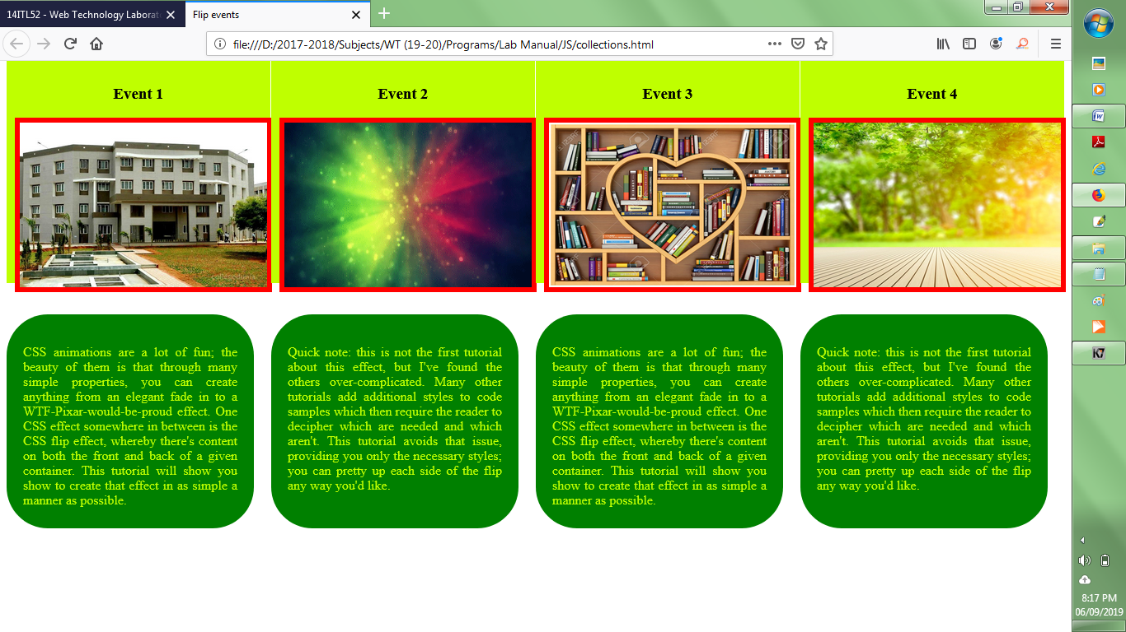

***v) Demonstration of JavaScript DOM – Dynamic creation and Insertion of Elements***

<html>

<head>

<title>Student Registration Form</title>

<style>

body{

background-image:url("../Images/brick wall.jpg");

background-size:150px;

}

td{

font-weight:bold;

color:brown;

}

</style>

</head>

<body>

<div style="background-color:brown;text-align:center;height:140px;position:absolute;top:0;left:0;width:100%;"><h1 style="color:lightyellow;">JavaScript - Document Object Model </h1>

<h2>(Usage of createElement(), appendChild(), and getElementsByName()) </h2>

<h1 style="background-color:lightyellow;text-align:center;">STUDENT REGISTRATION FORM</h1>

</div>

<table align="center" cellpadding = "10" style="background-color:rgb(255,242,176);border-radius:18px;width:800px;position:absolute;top:200px;left:250px;">

<!----- First Name ---------------------------------------------------------->

<tr>

<td>FIRST NAME</td>

<td><input type="text" name="First_Name" maxlength="30"/>

(max 30 characters a-z and A-Z)

</td>

</tr>

<!----- Last Name ---------------------------------------------------------->

<tr>

<td>LAST NAME</td>

<td><input type="text" name="Last_Name" maxlength="30"/>

(max 30 characters a-z and A-Z)

</td>

</tr>

<!----- Date Of Birth -------------------------------------------------------->

<tr>

<td>DATE OF BIRTH</td>

<td>

<select name="Birthday_day" id="Birthday_Day">

<option value="-1">Day:</option>

<option value="1">1</option>

<option value="2">2</option>

<option value="3">3</option>

<option value="4">4</option>

<option value="5">5</option>

<option value="6">6</option>

<option value="7">7</option>

<option value="8">8</option>

<option value="9">9</option>

<option value="10">10</option>

<option value="11">11</option>

<option value="12">12</option>

<option value="13">13</option>

<option value="14">14</option>

<option value="15">15</option>

<option value="16">16</option>

<option value="17">17</option>

<option value="18">18</option>

<option value="19">19</option>

<option value="20">20</option>

<option value="21">21</option>

<option value="22">22</option>

<option value="23">23</option>

<option value="24">24</option>

<option value="25">25</option>

<option value="26">26</option>

<option value="27">27</option>

<option value="28">28</option>

<option value="29">29</option>

<option value="30">30</option>

<option value="31">31</option>

</select>

<select id="Birthday_Month" name="Birthday_Month">

<option value="-1">Month:</option>

<option value="January">Jan</option>

<option value="February">Feb</option>

<option value="March">Mar</option>

<option value="April">Apr</option>

<option value="May">May</option>

<option value="June">Jun</option>

<option value="July">Jul</option>

<option value="August">Aug</option>

<option value="September">Sep</option>

<option value="October">Oct</option>

<option value="November">Nov</option>

<option value="December">Dec</option>

</select>

<select name="Birthday_Year" id="Birthday_Year">

<option value="-1">Year:</option>

<option value="2012">2012</option>

<option value="2011">2011</option>

<option value="2010">2010</option>

<option value="2009">2009</option>

<option value="2008">2008</option>

<option value="2007">2007</option>

<option value="2006">2006</option>

<option value="2005">2005</option>

<option value="2004">2004</option>

<option value="2003">2003</option>

<option value="2002">2002</option>

<option value="2001">2001</option>

<option value="2000">2000</option>

<option value="1999">1999</option>

<option value="1998">1998</option>

<option value="1997">1997</option>

<option value="1996">1996</option>

<option value="1995">1995</option>

<option value="1994">1994</option>

<option value="1993">1993</option>

<option value="1992">1992</option>

<option value="1991">1991</option>

<option value="1990">1990</option>

<option value="1989">1989</option>

<option value="1988">1988</option>

<option value="1987">1987</option>

<option value="1986">1986</option>

<option value="1985">1985</option>

<option value="1984">1984</option>

<option value="1983">1983</option>

<option value="1982">1982</option>

<option value="1981">1981</option>

<option value="1980">1980</option>

</select>

</td>

</tr>

<!----- Email Id ---------------------------------------------------------->

<tr>

<td>EMAIL ID</td>

<td><input type="text" name="Email_Id" maxlength="100" /></td>

</tr>

<!----- Mobile Number ---------------------------------------------------------->

<tr>

<td>MOBILE NUMBER</td>

<td>

<input type="text" name="Mobile_Number" maxlength="10" />

(10 digit number)

</td>

</tr>

<!----- Gender ----------------------------------------------------------->

<tr>

<td>GENDER</td>

<td>

Male <input type="radio" name="Gender" value="Male" />

Female <input type="radio" name="Gender" value="Female" />

</td>

</tr>

<!----- Address ---------------------------------------------------------->

<tr>

<td>ADDRESS <br /><br /><br /></td>

<td><textarea name="Address" rows="4" cols="30"></textarea></td>

</tr>

<!----- City ---------------------------------------------------------->

<tr>

<td>CITY</td>

<td><input type="text" name="City" maxlength="30" />

(max 30 characters a-z and A-Z)

</td>

</tr>

<!----- Pin Code ---------------------------------------------------------->

<tr>

<td>PIN CODE</td>

<td><input type="text" name="Pin_Code" maxlength="6" />

(6 digit number)

</td>

</tr>

<!----- State ---------------------------------------------------------->

<tr>

<td>STATE</td>

<td><input type="text" name="State" maxlength="30" />

(max 30 characters a-z and A-Z)

</td>

</tr>

<!----- Country ---------------------------------------------------------->

<tr>

<td>COUNTRY</td>

<td><input type="text" name="Country" value="India" readonly="readonly" /></td>

</tr>

<!----- Hobbies ---------------------------------------------------------->

<tr>

<td>HOBBIES <br /><br /><br /></td>

<td>

Drawing

<input type="checkbox" name="Hobby" value="Drawing" />

Singing

<input type="checkbox" name="Hobby" value="Singing" />

Dancing

<input type="checkbox" name="Hobby" value="Dancing" />

Sketching

<input type="checkbox" name="Hobby" value="Cooking" />

<br />

Others

<input type="checkbox" name="Hobby" value="Other" onclick="Display(this)"/>

<span id="other"></span>

<!--<input type="text" name="others" maxlength="30" />-->

</td>

</tr>

<!----- Qualification---------------------------------------------------------->

<tr>

<td onclick="getQual()">QUALIFICATION </td>

<td id="edu"></td>

</tr>

<!----- Course ---------------------------------------------------------->

<tr>

<td>COURSES<br />APPLIED FOR</td>

<td>

BCA

<input type="radio" name="Course_BCA" value="BCA">

B.Com

<input type="radio" name="Course_BCom" value="B.Com">

B.Sc

<input type="radio" name="Course_BSc" value="B.Sc">

B.A

<input type="radio" name="Course_BA" value="B.A">

</td>

</tr>

<!----- Submit and Reset ------------------------------------------------->

<tr>

<td colspan="2" align="center">

<input type="submit" value="Submit">

<input type="reset" value="Reset">

</td>

</tr>

</table>

</form>

<script>

function Display(e)

{

var ot=document.getElementById("other");

var t1 = document.createElement("input");

t1.setAttribute("type","textarea");

t1.setAttribute("rows","5");

t1.setAttribute("cols","150");

t1.setAttribute("placeholder","Specify other hobbies");

if(e.checked)

ot.appendChild(t1);

else

ot.innerHTML=" ";

}

function getQual()

{

var elt=document.getElementById("edu");

var ten1 = document.createElement("input");

ten1.setAttribute("type","text");

var ten2 = document.createElement("input");

ten2.setAttribute("type","text");

var ten3 = document.createElement("input");

ten3.setAttribute("type","text");

var plus21 = document.createElement("input");

plus21.setAttribute("type","text");

var plus22 = document.createElement("input");

plus22.setAttribute("type","text");

var plus23 = document.createElement("input");

plus23.setAttribute("type","text");

var ug1 = document.createElement("input");

ug1.setAttribute("type","text");

var ug2 = document.createElement("input");

ug2.setAttribute("type","text");

var ug3 = document.createElement("input");

ug3.setAttribute("type","text");

var tbl = document.createElement("table");

tbl.setAttribute("bgcolor","brown");

var row1 = tbl.insertRow(0);

var row2= tbl.insertRow(1);

var row3=tbl.insertRow(2);

var row4=tbl.insertRow(3);

var cell11 = row1.insertCell(0);

var cell12 = row1.insertCell(1);

var cell13 = row1.insertCell(2);

var cell14 = row1.insertCell(3);

var cell15 = row1.insertCell(4);

var cell21 = row2.insertCell(0);

var cell22 = row2.insertCell(1);

var cell23 = row2.insertCell(2);

var cell24 = row2.insertCell(3);

var cell25 = row2.insertCell(4);

var cell31 = row3.insertCell(0);

var cell32 = row3.insertCell(1);

var cell33 = row3.insertCell(2);

var cell34 = row3.insertCell(3);

var cell35 = row3.insertCell(4);

var cell41 = row4.insertCell(0);

var cell42 = row4.insertCell(1);

var cell43 = row4.insertCell(2);

var cell44 = row4.insertCell(3);

var cell45 = row4.insertCell(4);

var h="<h3 style='color:rgb(255,242,176);text-align:center;'>"

var ch="<span style='color:rgb(255,242,176);'>"

cell11.innerHTML = h+"S.No.</h3>";

cell12.innerHTML = h+"Qualification</h3>";

cell13.innerHTML = h+"Board/University</h3>";

cell14.innerHTML = h+"Percentage</h3>";

cell15.innerHTML = h+"Year of Passing</h3>";

cell21.innerHTML=ch+"1</span>"

cell22.innerHTML=ch+"Class X</span>"

cell23.appendChild(ten1);

cell24.appendChild(ten2);

cell25.appendChild(ten3);

cell31.innerHTML=ch+"2</span>"

cell32.innerHTML=ch+"Class XII</span>"

cell33.appendChild(plus21);

cell34.appendChild(plus22);

cell35.appendChild(plus23);

cell41.innerHTML=ch+"3</span>"

cell42.innerHTML=ch+"UG Degree</span>"

cell43.appendChild(ug1);

cell44.appendChild(ug2);

cell45.appendChild(ug3);

elt.appendChild(tbl);

}

</script>

</body>

</html>

**Output:**

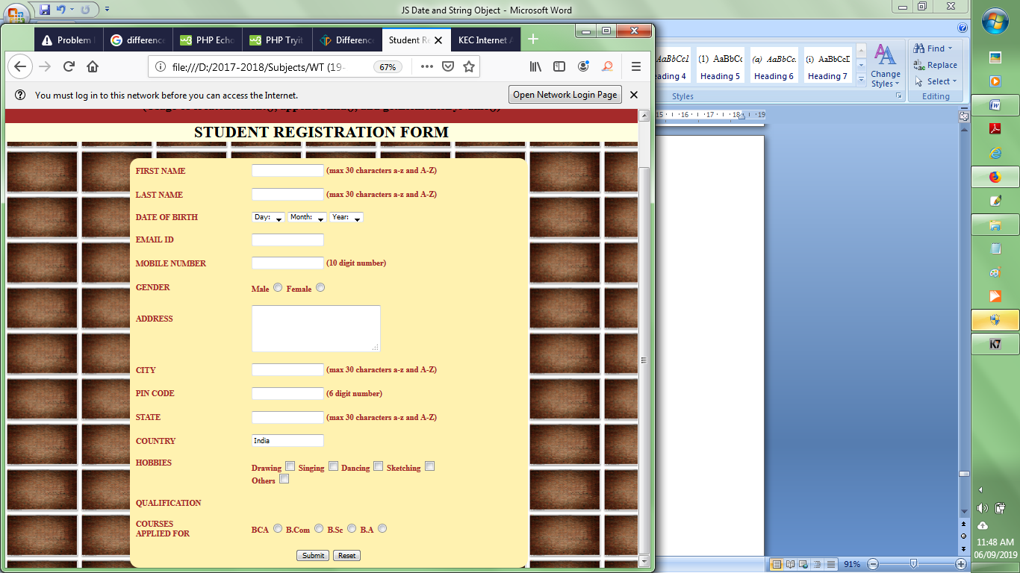

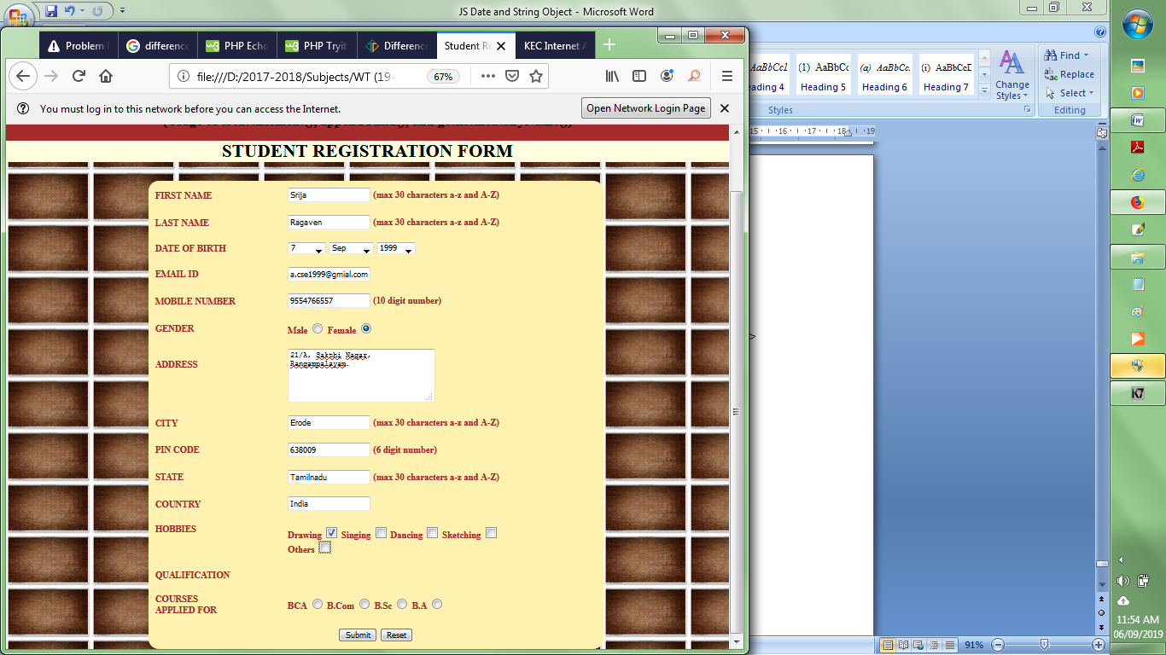

**After creating and inserting necessary fields for other hobbies and qualification**

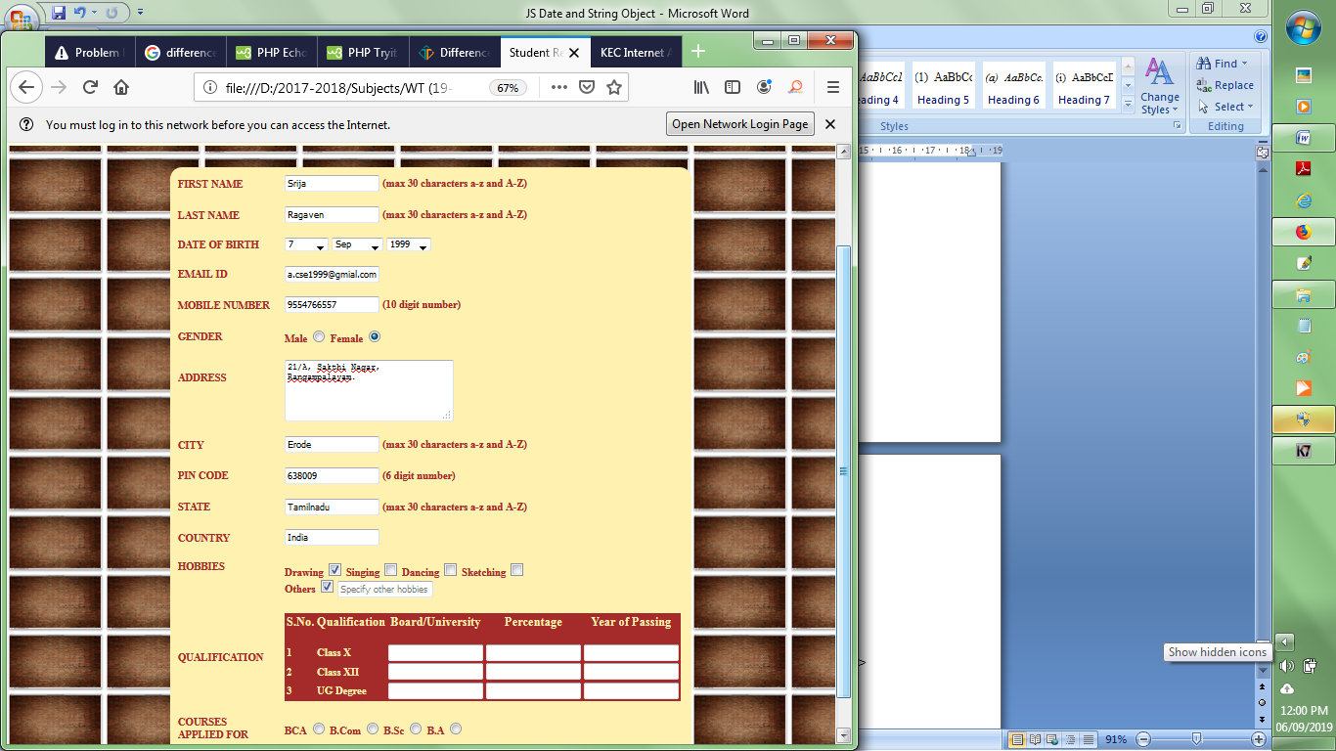

**Result:**

Thus simple web pages have been designed and developed by applying JavaScript objects and collections

**Viva Questions:**

|  |  |
| --- | --- |
| **1.** | Write a JavaScript function named Words() to create an array of words from a given sentence. Pass the sentence as argument to the function and display the words as an unordered list. |
| **2.** | Write a JavaScript function to round a number to a given decimal places.  Test Data : Input : 12.375,2 Output: 12.38  Input : 12.37499,2 Output:12.37 Input : -10.3079499, 3 Output: -10.308 |
| **3.** | Write a JavaScript function to check to check whether a variable is numeric or not |
| **4.** | Create a Pythagorean function in JavaScript. Note : The Pythagorean Theorem tells us that the relationship in every right triangle is : c2 = a2 + b2, where c is the hypotenuse and a, b are two legs of the triangle.  Test Data : console.log(pythagorean_theorem(2, 4));  console.log(pythagorean_theorem(3, 4)); Output : 4.47213595499958  5 |
| **5.** | Write a JavaScript function to convert a string in abbreviated form.  Ex: Input- Web Technology Output- WT |
| **6.** | Write a JavaScript function to capitalize the first letter of a string. [Go to the editor](https://www.w3resource.com/javascript-exercises/javascript-string-exercises.php#EDITOR) Test Data : console.log(capitalize('js string exercises')); "Js string exercises" |
| **7.** | Write a JavaScript code to get radius and calculate the volume of a sphere and display the same in the provided textbox. Make use of appropriate DOM methods to fetch value from the textbox and display value in the textbox.  javascript-dom-exercise-9. |
| **8.** | Write a JavaScript program to count and display the items of a dropdown list in an alert window.  Sample HTML file :  <!DOCTYPE html>  <html><head>  <meta charset=utf-8 />  <style type="text/css">  body {margin: 30px;}  </style>  <title>Count and display items of a dropdown list - w3resource</title>  </head><body><form>  Select your favorite Color :  <select id="mySelect">  <option>Red</option>  <option>Green</option>  <option>Blue</option>  <option>White</option>  </select>  <input type="button" onclick="getOptions()" value="Count and Output all items">  </form></body></html> |
| **9.** | Write a JavaScript function to get the number of days in a month. |
| **10.** | Write a JavaScript function to test whether a date is a weekend. |

**Experiment 7:**

**DEVELOP INTERACTIVE WEB PAGES USING EVENT HANDLING IN JAVASCRIPT**

**Aim: To design web pages to demonstrate DOM and Event-handling in JavaScript**

**Description:**

*JavaScript events* - allow scripts to respond to user interactions and modify the page

accordingly. Events and event handling help make web applications more dynamic and

interactive

*Registering an Event Handler*

* General syntax to attach an event for any HTML element

x.addEventListener(“click”,change,false)

* + x🡪 JavaScript variable referring the HTML element
  + click🡪event to be raised by the HTML element
  + change🡪JavaScript function to be invoked when the element is clicked
  + false🡪default argument
* Two other event-registration models—the inline model and the traditionalmodel
* Inline model places calls to JavaScript functions directly in HTML code as shown below

<img onclick=”change” src=”p1.jpg”/>

* + click🡪event to be raised by the HTML element
  + change🡪JavaScript function to be invoked during the event
* Traditional model uses a property of an object to specify an event handler as shown below

x.onclick **= "change()"**;

* + x🡪JavaScript variable referring the HTML element
  + change()🡪JavaScript function that is called when the element is clicked
* List of Events that are applied: click, mouseover, mouseout, Form Events - focus, blur
* HTML Elements used to design the web pages:
  + Form elements: <form>, <select>, <option>, <input> - type: text, date, radio, checkbox, button
  + Basic HTML tags: <img>,<h1>,<table>,<tr>,<td>
* DOM methods: getElementById( ), getElementsByName( )

**Program**

1. ***Click, Focus, and Blur Events – Students Personal Information***

<html>

<head><title>Student's Personal Info using DOM and Event-Handling</title>

<style>

div{

width:400px;

height:auto;

background-color:rgb(48, 70, 232);

opacity:.9;

position:fixed;top:50px;left:450px;

text-align:left;

overflow:auto;

}

form{

font-size:12pt;

font-weight:bold;

margin-left:50px;

color:white;

}

</style>

</head>

<body style="background-image:url('../Images/bg.png');">

<div>

<h1 style="text-align:center;color:yellow;">Personal Details</h1>

<form>

<label> Name</label>

<input type="text" id="uname" value=" " onfocus="tip()" onblur="del()"/><br/>

<span id="tips" style="font-size:8pt;color:brown;"></span><br/>

<label>Date of Birth</label>

<input type="date" id="dob" value=" " onblur="calcAge()"/><br/><br/>

<label>Age</label>

<input type="text" id="age" value=" "/><br/><br/>

<label>Year of Study</label>

<select id="yr">

<option>Select</option>

<option value="I">I</option>

<option value="II">II</option>

<option value="III">III</option>

<option value="IV">IV</option>

</select><br/><br/>

<label>Community</label>

<input type="radio" name="com" value="OC"/>OC

<input type="radio" name="com" value="BC" />BC

<input type="radio" name="com" value="MBC"/>MBC<br/><br/>

<label>Hobbies</label><br/>

<input type="checkbox" name="hobs" value="Singing"/><label>Singing</label><br/>

<input type="checkbox" name="hobs" value="Art and Craft" />

<label>Art and Craft</label><br/>

<input type="checkbox" name="hobs" value="Instrumental Music"/>

<label>Instrumental Music</label><br/>

<input type="checkbox" name="hobs" value="Fashion Design"/>

<label>Fashion Design</label><br/>

<input type="checkbox" name="hobs" value="Games"/><label>Games</label><br/>

<input type="checkbox" name="hobs" value="Script Writing"/>

<label>Script Writing</label><br/>

<br/>

<label>Emial-ID</label>

<input type="email" id="mail" value=" " required/><br/><br/>

<label>Mobile No.</label>

<input type="text" id="mobileno" value=" " required/><br/>

<input type="button" value="Register" onclick="Move()"/><br/>

</form>

</div>

<p style="color:yellow;font-size:15pt;position:absolute;right:0px;top:100px;background-color:yellowgreen;width:300px;" id="res">welcome</p>

<script>

var Name,comm,mydob,myage,para,sk,year,hobbies=" ";

var email,phno,l1,l2;

Name=document.getElementById("uname");

year=document.getElementById("yr");

var t=document.getElementById("tips");

function tip()

{

t.innerHTML="Enter your name in UpperCase";

}

function del()

{

t.innerHTML=" ";

}

function calcAge()

{

var yr,age,s;

var current=new Date();

t.innerHTML=" ";

mydob=document.getElementById("dob").value;

s=mydob.split('-');

alert(s[0]);

myage=document.getElementById("age");

age=current.getFullYear()-parseInt(s[0]);

myage.value=age;

myage.readOnly=true;

year.focus();

}

function Move()

{

email=document.getElementById("mail").value;

pho=document.getElementById("mobileno").value;

para=document.getElementById("res");

comm=document.getElementsByName("com");

sk=document.getElementsByName("hobs");

l1=comm.length;

l2=sk.length;

for(var i=0;i<l1;i++)

{

if(comm[i].checked)

{ c=comm[i].value;

break;

}

}

for(var j=0;j<l2;j++)

{

if(sk[j].checked)

{ hobbies+=sk[j].value+"<br/> ";

}

}

para.innerHTML="Your Name: "+Name.value+"<br/>Your are in: "+year.value+"<br/>Your Age: "+myage.value+"<br/>You belong to:"+c+"<br/>Your Hobbies:"+hobbies;

para.innerHTML+="<br/>Email ID: "+email+"<br/>Mobile No.: "+pho;

//para.innerHTML="Registration successfull";

}

</script>

</body>

</html>

**Output:**

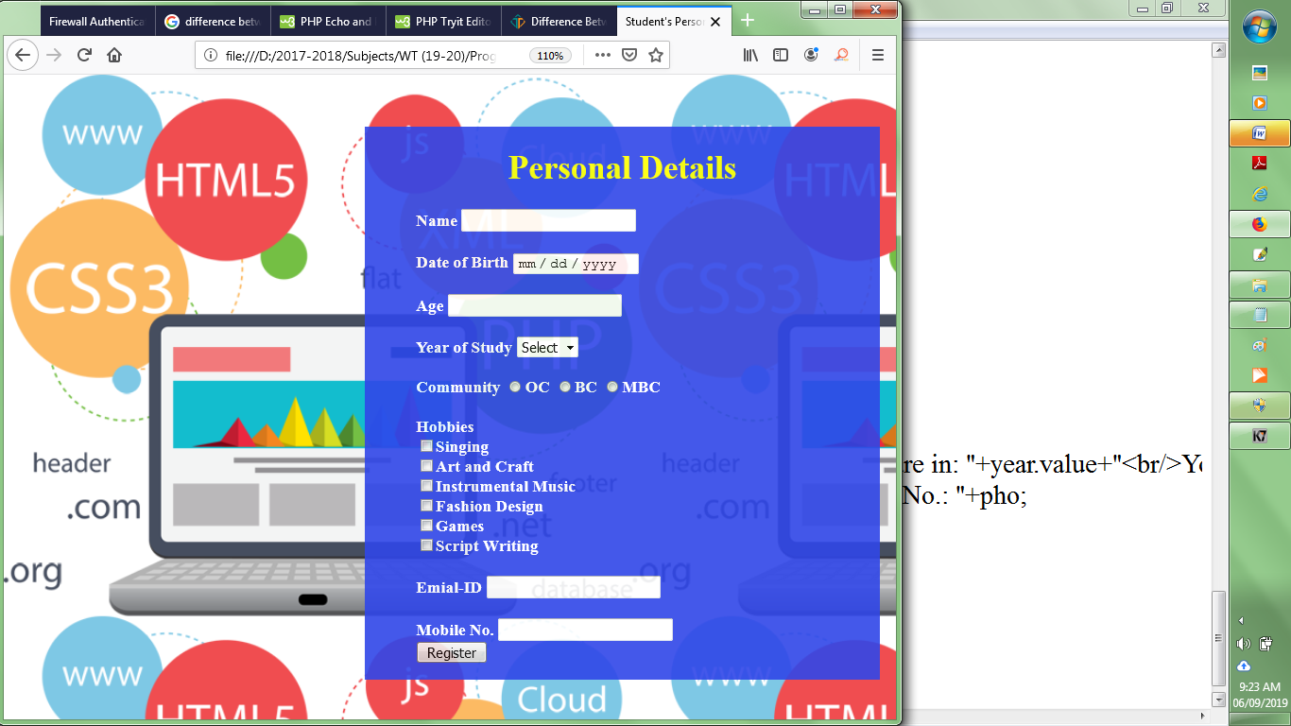

**Focus Event**

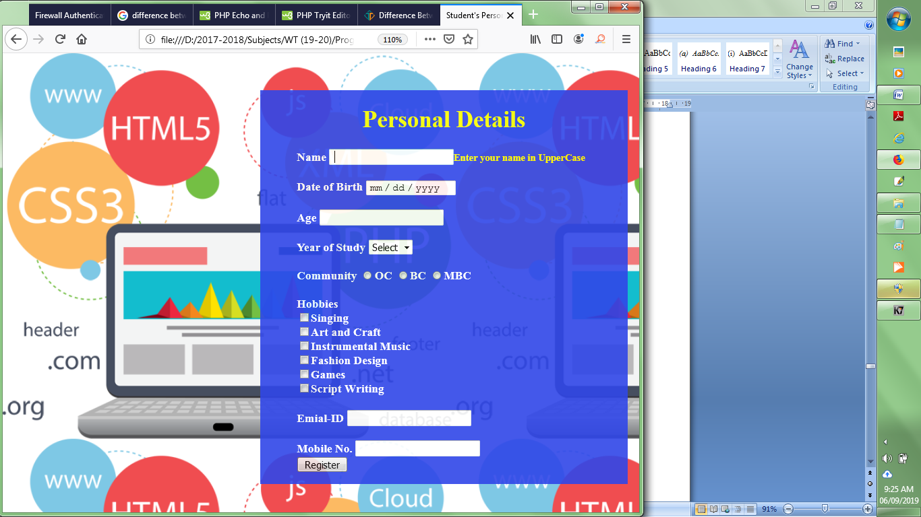

**Blur Event**

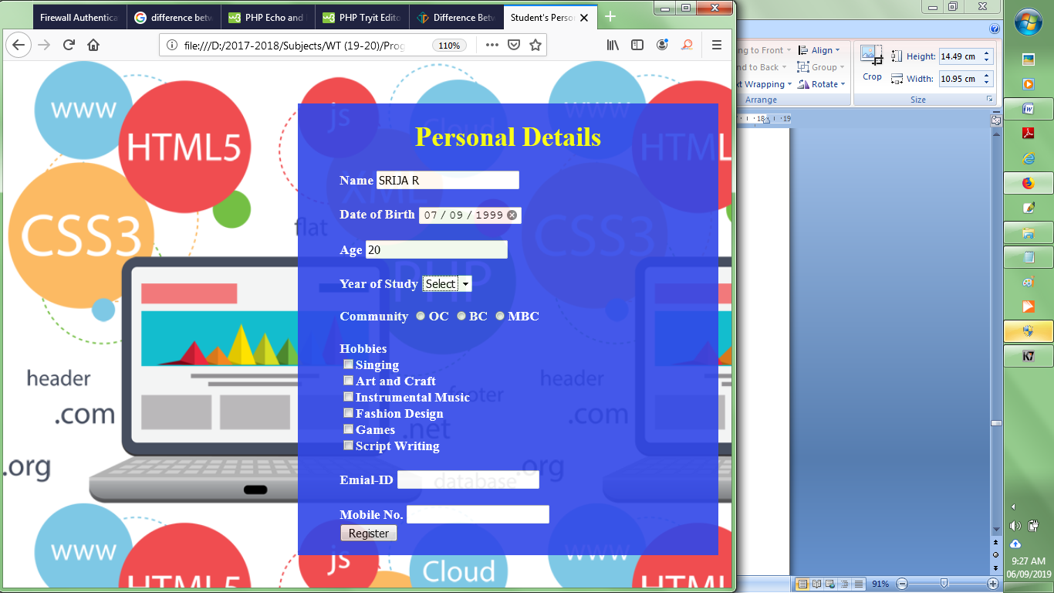

**Click Event**

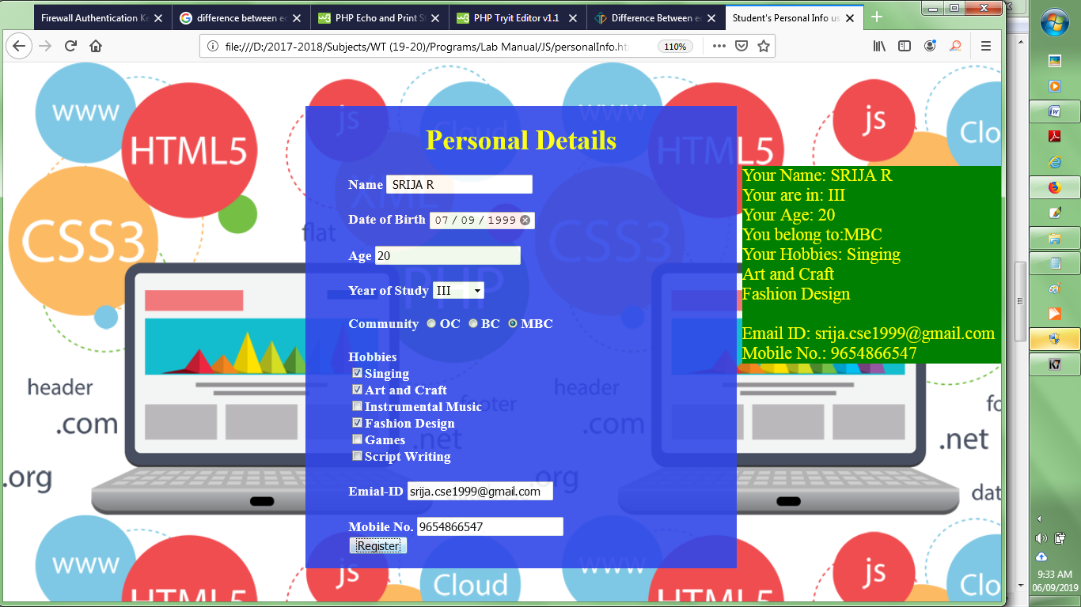

1. ***MouseOver and MouseOut – Changing the Pictures***

<html>

<head>

<title>MouseOver and MouseOut Events</title>

<style>

img{

width:500px;

height:500px;

}

body{

background-image:url("../Images/bgNew.jpg");

}

</style>

</head>

<body id="b">

<table>

<tr><td><h1 id="text1">Beautiful Puppies</h1> </td></tr>

<tr><td><img id="pic1" src="../Images/dogs.jpg"/></td></tr>

</table>

<input type="button" id="myBtn" value="Change Pic"/>

<div> </div>

<script>

var para,b1,img1,text;

text=document.getElementById("text1");

b1=document.getElementById("myBtn");

img1=document.getElementById("pic1");

img1.addEventListener("mouseover", myFunction2);

img1.addEventListener("mouseout", myFunction3);

function myFunction1()

{

var pic=document.getElementById("pic1");

text.innerHTML="Cute Kittens";

pic.src='../Images/cats.jpg';

}

function myFunction2()

{

var pic=document.getElementById("pic1");

text.innerHTML="Cute Little Angel";

text.style.fontColor="blue";

pic.src='../Images/pic2.jpg';

}

function myFunction3()

{

var pic=document.getElementById("pic1");

text.innerHTML="Beautiful Puppies";

text.style.fontColor="Purple";

pic.src='../Images/dogs.jpg';

}

b1.addEventListener("click", myFunction1);

</script>

</body>

</html>

**Output:**

|  |  |
| --- | --- |
| Before MouseOver | After MouseOver |

1. ***Click Event and Arrays to design a Web Page for Slide Show***

<html>

<head>

<title>Slide Show</title>

<style>

body{

background-image:url("../Images/bgNew1.jpg");

background-size:cover;

}

input{

font-size:18pt;

color:white;

background-color:black;

font-family:cambria;

}

</style>

<body id="b">

<table>

<tr> <td colspan="2"><img id="pic1" src="../Images/Birds/b1.jpg" width="700px" height="500px"/></td>

</tr>

<tr> <td><input type="button" id="prev" value="<"/></td>

<td style="text-align:right;"><input type="button" id="next" value=">"/></td>

</tr>

</table>

<script>

var imgs= ["b1.jpg","b2.jpg","b3.jpg","b4.jpg","b5.jpg","b6.jpg","b7.jpg","b8.jpg","b9.jpg", "b10.jpg","b11.jpg","b12.jpg","b13.jpg","b14.jpg","b15.jpg"];

var i=0;

var Next=document.getElementById("next");

var Prev=document.getElementById("prev")

var pic=document.getElementById("pic1");

function myFunction1()

{

pic.src="../Images/Birds/"+imgs[i];

i++;

var l=imgs.length-1;

if(i>l)

pic.src="../Images/Birds/"+imgs[l];

}

function myFunction2()

{

i--;

pic.src="../Images/Birds/"+imgs[i];

if(i<0)

pic.src="../Images/Birds/"+imgs[0];

}

Next.addEventListener("click", myFunction1,false);

Prev.addEventListener("click", myFunction2,false);

</script>

</body>

</html>

**Output:**

|  |  |
| --- | --- |
|  |  |

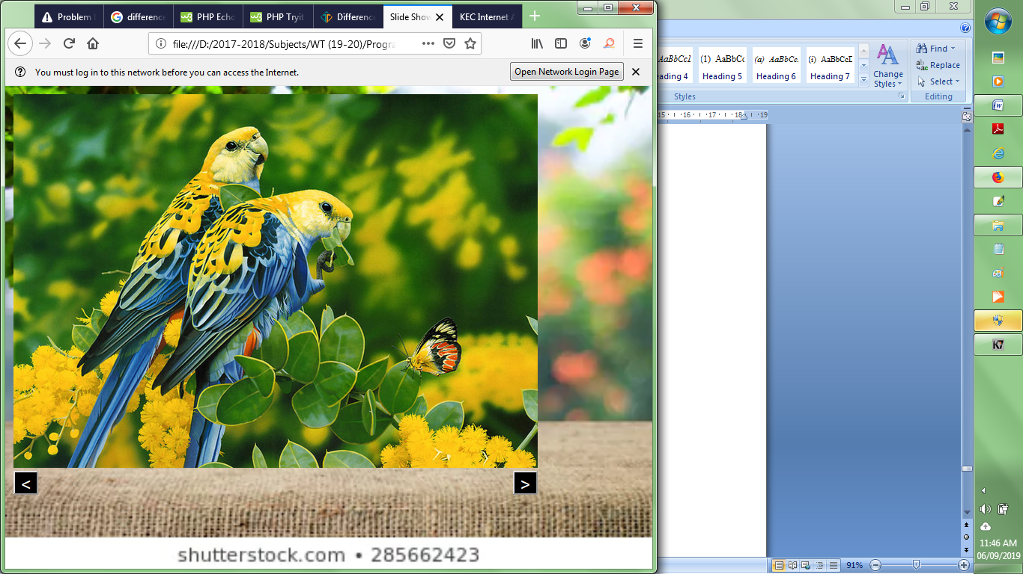

**Result:**

Thus interactive web pages have been developed using JavaScript Events

**Viva Questions:**

1. You have a server-side script that cannot handle any ampersands (&) in the form data. Write

a function that converts all ampersands in a form field to " and " when the field loses focus (blur).

2. Design a web page with a button on it. Write a JavaScript code to display the no. of times the user has clicked the button.

3. Display a list of colors as a dropdown list. Write a JavaScript code to apply the color selected by the user as the background color for the web page. Apply the color once the user selects it from the dropdown list.

4. Predit the output of the following code:

<html>

<head>

<title>t1</title>

<script type="text/javascript">

function addNode() { var newP = document.createElement("p");

var textNode = document.createTextNode(" This is a new text node");

newP.appendChild(textNode); document.getElementById("firstP").appendChild(newP); }

</script> </head>

<body> <p id="firstP">firstP<p> </body>

</html>

5. Add suitable JavaScript code to the code given below to add a new ‘img’ element to display an image before the paragraph content.

<html>

<head>

<title>t1</title>

</head>

<body> <p id="firstP">firstP<p> </body>

</html>

6. Write the output of the code given below

var a = [1, 2, 3];

a[7]=10;

document.write(a[5]);

7. Consider the following HTML code

<html>

<head></head>

<body>

<h6> Welcome </h6>

</body>

</html>

Write suitable JavaScript code to increase the size of the text ‘Welcome’ when the user moves the mouse pointer over that text.

8. Design a simple web form to get name of a student as input. Write a JavaScript code to popup an alert message “Type in Uppercase”, when the input field gets focus.

9. Attach click event to the button in the code given below and write a JavaScript code to modify the style (font, font size, and color) of the paragraph text.

<!DOCTYPE html>

<html>  
<head>

<meta charset=utf-8 />

<title>JS DOM paragraph style</title>

</head>

<body>

<p id ='text'>JavaScript Exercises - w3resource</p>

<div>

<button>Style</button>

</div>

</body>

</html>

10. Write a JavaScript function named ‘insert_Row()’ to add two more rows to the table in the following HTML code.

<!DOCTYPE html>

<html><head>  
<meta charset=utf-8 />

<title>Insert row in a table - w3resource</title>

</head><body>

<table id="sampleTable" border="1">

<tr><td>Row1 cell1</td>

<td>Row1 cell2</td></tr>

<tr><td>Row2 cell1</td>

<td>Row2 cell2</td></tr>

</table><br>

<input type="button" onclick="insert_Row()" value="Insert row">

</body></html>

**Experiment 8:**

**DESIGN AND DEVELOP AN ONLINE INTERACTIVE CGPA CALCULATOR**

**Aim:** To develop an online CGPA calculator using HTML and JavaScript

**Description:**

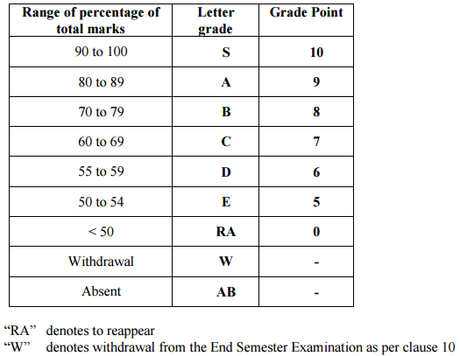

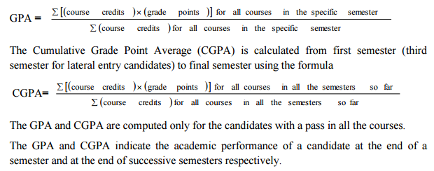

**Program:**

<html>

<head><title>CGPA Calculator</title>

<style>

body{

background-image:url("../Images/bgNew2.jpg");

background-size:cover;

}

td,select{

font-size:13pt;

color:purple;

text-align:center;

}

</style>

<script src="../Script/cgpa.js">

</script>

</head>

<body>

<table bgcolor="lightgreen" cellspacing="2" cellpadding="3" width="700px" style="border-radius:20px;position:absolute;top:70px;left:300px;">

<tr>

<td colspan="5"><h1 style="background-color:purple;text-align:center;color:orange;height:50px;padding-top:13px;border-radius:20px;">GPA Calculator</h1></td>

</tr>

<tr style="font-weight:bold;">

<td>Course</td>

<td>Credits</td>

<td>Grade</td>

<td>Grade Points</td>

<td>Grade Point X Credit</td>

</tr>

<tr>

<td>Course 1</td>

<td>

<select name="credit">

<option>-</option>

<option value="1">1</option>

<option value="2">2</option>

<option value="3">3</option>

</select>

</td>

<td>

<select name="grade">

<option>-</option>

<option value="S">S</option>

<option value="A">A</option>

<option value="B">B</option>

<option value="C">C</option>

<option value="D">D</option>

<option value="E">E</option>

</select>

</td>

<td name="pts"></td>

<td name="gpa"></td>

</tr>

<tr>

<td>Course 2</td>

<td>

<select name="credit">

<option>-</option>

<option value="1">1</option>

<option value="2">2</option>

<option value="3">3</option>

</select>

</td>

<td>

<select name="grade">

<option>-</option>

<option value="S">S</option>

<option value="A">A</option>

<option value="B">B</option>

<option value="C">C</option>

<option value="D">D</option>

<option value="E">E</option>

</select>

</td>

<td name="pts"></td>

<td name="gpa"></td>

</tr>

<tr>

<td>Course 3</td>

<td>

<select name="credit">

<option>-</option>

<option value="1">1</option>

<option value="2">2</option>

<option value="3">3</option>

</select>

</td>

<td>

<select name="grade">

<option>-</option>

<option value="S">S</option>

<option value="A">A</option>

<option value="B">B</option>

<option value="C">C</option>

<option value="D">D</option>

<option value="E">E</option>

</select>

</td>

<td name="pts"></td>

<td name="gpa"></td>

</tr>

<tr>

<td>Course 4</td>

<td>

<select name="credit">

<option>-</option>

<option value="1">1</option>

<option value="2">2</option>

<option value="3">3</option>

</select>

</td>

<td>

<select name="grade">

<option>-</option>

<option value="S">S</option>

<option value="A">A</option>

<option value="B">B</option>

<option value="C">C</option>

<option value="D">D</option>

<option value="E">E</option>

</select>

</td>

<td name="pts"></td>

<td name="gpa"></td>

</tr>

<tr>

<td>Course 5</td>

<td>

<select name="credit">

<option>-</option>

<option value="1">1</option>

<option value="2">2</option>

<option value="3">3</option>

</select>

</td>

<td>

<select name="grade">

<option>-</option>

<option value="S">S</option>

<option value="A">A</option>

<option value="B">B</option>

<option value="C">C</option>

<option value="D">D</option>

<option value="E">E</option>

</select>

</td>

<td name="pts"></td>

<td name="gpa"></td>

</tr>

<tr>

<td>Course 6</td>

<td>

<select name="credit">

<option>-</option>

<option value="1">1</option>

<option value="2">2</option>

<option value="3">3</option>

</select>

</td>

<td>

<select name="grade">

<option>-</option>

<option value="S">S</option>

<option value="A">A</option>

<option value="B">B</option>

<option value="C">C</option>

<option value="D">D</option>

<option value="E">E</option>

</select> </td>

<td name="pts"></td>

<td name="gpa"></td>

</tr>

<tr>

<td>Course 7</td>

<td>

<select name="credit">

<option>-</option>

<option value="1">1</option>

<option value="2">2</option>

<option value="3">3</option>

</select>

</td>

<td>

<select name="grade">

<option>-</option>

<option value="S">S</option>

<option value="A">A</option>

<option value="B">B</option>

<option value="C">C</option>

<option value="D">D</option>

<option value="E">E</option>

</select>

</td>

<td name="pts"></td>

<td name="gpa"></td>

</tr>

<tr>

<td>Course 8</td>

<td>

<select name="credit">

<option>-</option>

<option value="1">1</option>

<option value="2">2</option>

<option value="3">3</option>

</select>

</td>

<td>

<select name="grade">

<option>-</option>

<option value="S">S</option>

<option value="A">A</option>

<option value="B">B</option>

<option value="C">C</option>

<option value="D">D</option>

<option value="E">E</option>

</select>

</td>

<td name="pts"></td>

<td name="gpa"></td>

</tr>

<tr>

<td>Course 9</td>

<td>

<select name="credit">

<option>-</option>

<option value="1">1</option>

<option value="2">2</option>

<option value="3">3</option>

</select>

</td>

<td>

<select name="grade">

<option selected>-</option>

<option value="S">S</option>

<option value="A">A</option>

<option value="B">B</option>

<option value="C">C</option>

<option value="D">D</option>

<option value="E">E</option>

</select>

</td>

<td name="pts"></td>

<td name="gpa"></td>

</tr>

<tr>

<td colspan="5" align="center"><br/><input type="button" value="Calculate" onclick="Calc()" style="border-radius:10px;background-color:orange;color:green;font-size:15pt;font-family:cambria;font-weight:bold;width:100px;"/></td>

</tr>

<tr>

<td colspan="5" align="center"><br/><h3 style="color:purple;" id="res">Your CGPA:</h3><br/></td>

</tr>

</table>

</body>

</html>

cgpa.js

var credits=new Array();

var grade=new Array();

var gradePts=new Array();

var gpa=new Array();

var fcgpa,cgpa=0;

var c,g,pts,pVal;

var totalCredits=0;

var result=document.getElementById("res");

function Calc()

{

c=document.getElementsByName("credit");

g=document.getElementsByName("grade");

pts=document.getElementsByName("pts");

pVal=document.getElementsByName("gpa");

for(i=0;i<c.length;i++)

{

totalCredits+=parseInt(c[i].value);

}

for(i=0;i<g.length;i++)

{

grade[i]=g[i].value;

}

for(i=0;i<g.length;i++)

{

switch(g[i].value)

{

case 'S':

gradePts[i]=10;

break;

case 'A':

gradePts[i]=9;

break;

case 'B':

gradePts[i]=8;

break;

case 'C':

gradePts[i]=7;

break;

case 'D':

gradePts[i]=6;

break;

case 'E':

gradePts[i]=5;

break;

}

}

for(i=0;i<gradePts.length;i++)

{

gpa[i]=parseInt(c[i].value)*gradePts[i];

cgpa+=gpa[i];

pts[i].innerHTML=gradePts[i];

pVal[i].innerHTML=gpa[i];

}

fcgpa=cgpa/totalCredits;

res.innerHTML+=fcgpa.toFixed(2); ;

}

**Output:**

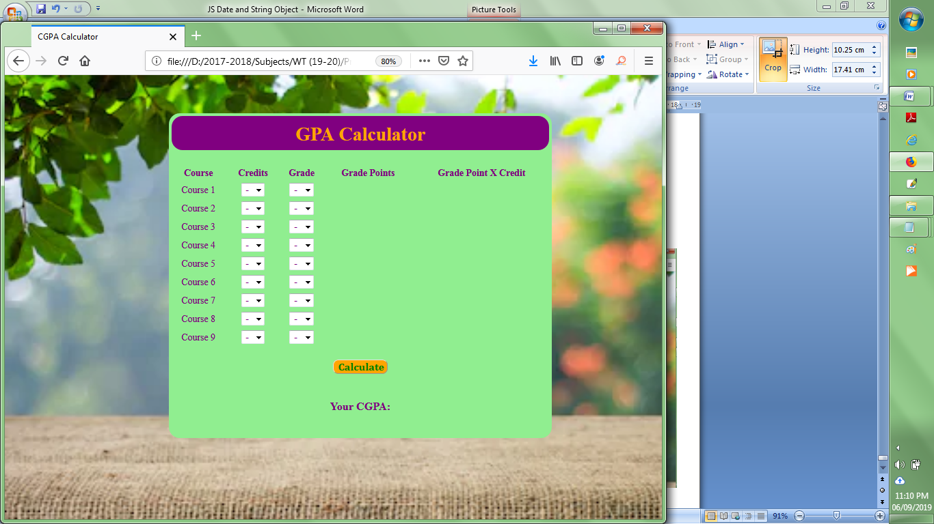

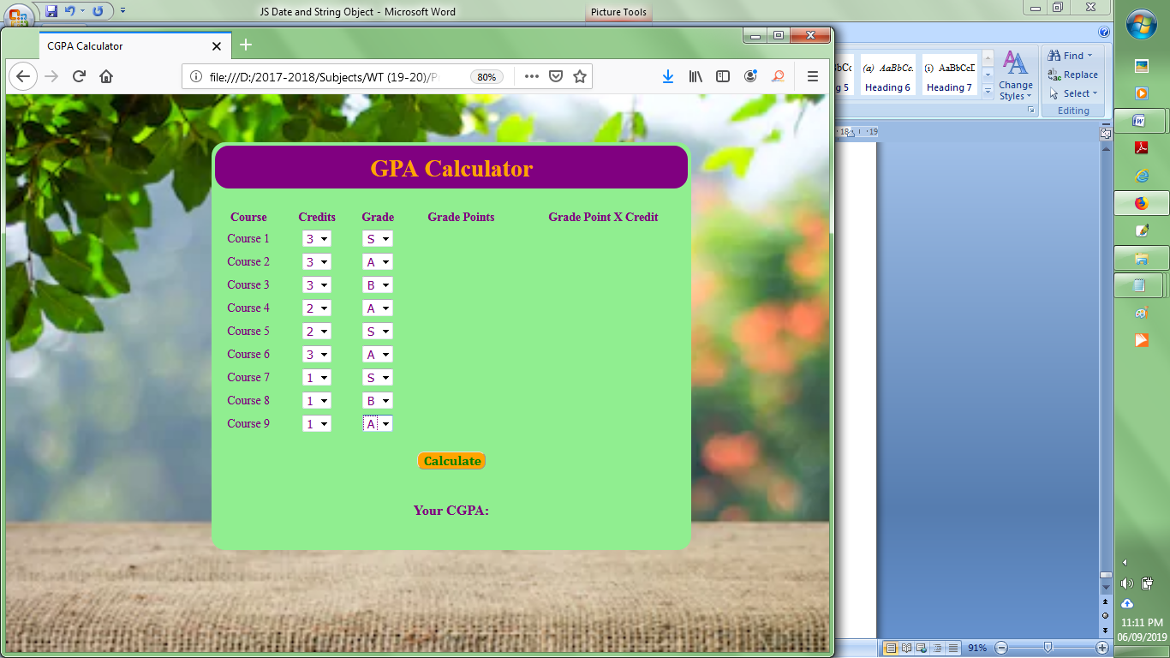

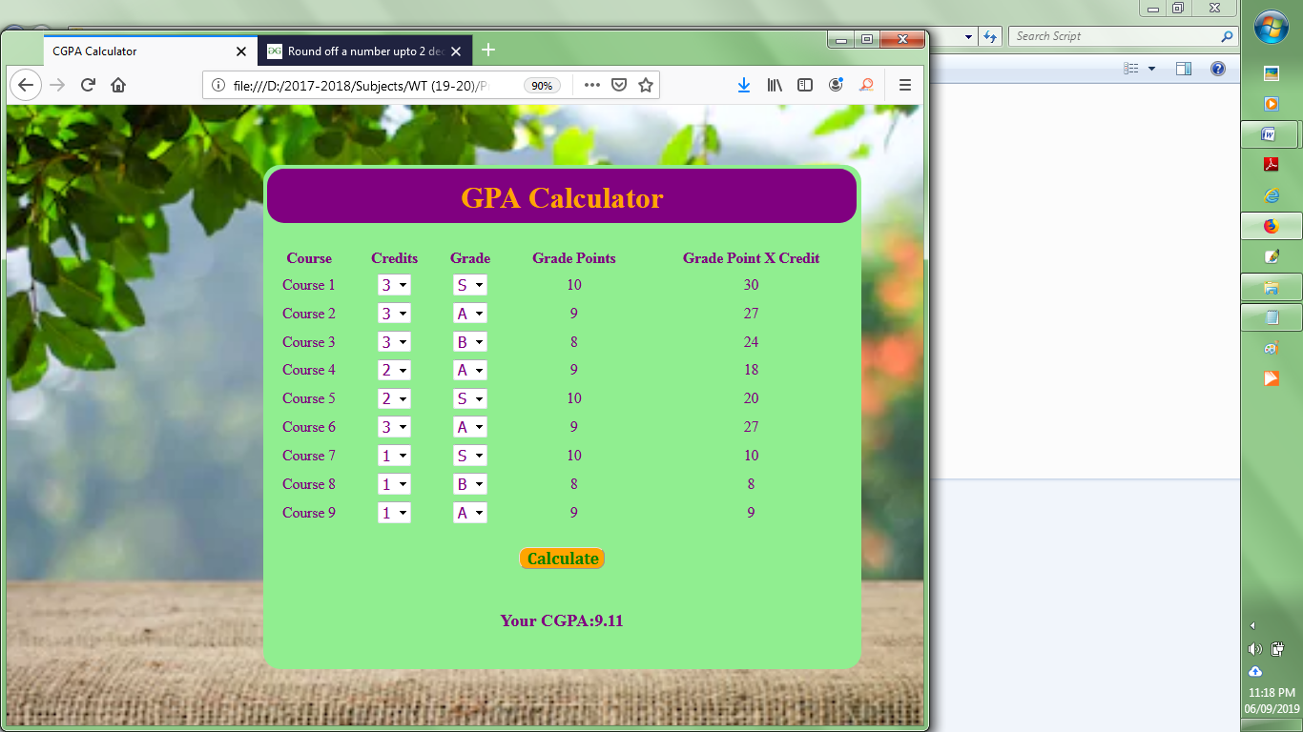

**Result:**

Thus an interactive CGPA calculator has been developed using HTML and JavaScript.

**Viva Questions**

|  |  |
| --- | --- |
| **1.** | Write a JavaScript function to convert a binary number to a decimal number.  Test Data : input 51  Output 110011 |
| **2.** | Write a JavaScript function to get the greatest common divisor (gcd) of two integers. |
| **3.** | Write a JavaScript function to find out if a number is a natural number or not. |
| **4.** | Write a JavaScript function to calculate the sum of values in an array. |
| **5.** | Write a JavaScript function to convert a positive number to negative number. |
| **6.** | Write a JavaScript function to get the highest number from three different numbers. |
| **7.** | Write a JavaScript function which will return values that are powers of two. |
| **8.** | Write a JavaScript function to print all prime numbers from 0 to a specified number. |
| **9.** | Write a JavaScript program to multiply two complex numbers. |
| **10.** | Write a JavaScript program to add two complex numbers. |

**Experiment 9:**

**DEVELOP A WEB PAGE TO IMPLEMENT AUTOCOMPLETION OF A TEXT FIELD UISNG AJAX WITH PHP**

**Aim:** To create a simple application that allows users to search for popular PHP MVC frameworks

# Description:

* AJAX is the acronym for Asynchronous [JavaScript](https://www.guru99.com/interactive-javascript-tutorials.html) & XML.
* It is a technology that reduces the interactions between the server and client.
* It does this by updating only part of a web page rather than the whole page.
* The asynchronous interactions are initiated by JavaScript.
* “if (str.length == 0)” check the length of the string. If it is 0, then the rest of the script is not executed.
* “if (window.XMLHttpRequest)…” Internet Explorer versions 5 and 6 use ActiveXObject for AJAX implementation. Other versions and browsers such as Chrome, FireFox use XMLHttpRequest. This code will ensure that our application works in both IE 5 & 6 and other high versions of IE and browsers.
* “xmlhttp.onreadystatechange=function…” checks if the AJAX interaction is complete and the status is 200, then updates the txtName span with the returned results.

However, if the input field is not empty, do the following:

* + 1. Create an XMLHttpRequestobject
    2. Define the function to be executed when the server response isready
    3. Send the request off to a PHP file (frameworks.php ) on the server
    4. Notice that q parameter is added to the url(framework.php?q="+str)
    5. And the str variable holds the content of the input field
    6. **XMLHttpRequest()** - Request data from server.
    7. **Xmlhttp.onrreadystatechange**- Defines a function to be called when the readystate property changes.
    8. **Xmlhttp.open()** – Specify the type of request
    9. **Xmlhttp.send()** - sends the request to the server

**Configuration steps:**

1. Install Xampp Web server and start the web server

2. Check whether your home page is opening in browserhttp://localhost:80

3. Deploy the files necessary for application in htdocs folder

4. Open the application in web browser and perform the operations.

**STEPS**:

1. A client event occurs. (the page is loaded, a button is clicked)
2. An XMLHttpRequest object is created. *variable* = new XMLHttpRequest();
3. The XMLHttpRequest object is configured.
   * **onreadystatechange** property defines a function to be executed when the readyState changes.
4. The XMLHttpRequest object makes an asynchronous request to the Webserver

open(method, url, async, user, psw)

method: the request type GET or POST  
 url: the file location  
 async: true (asynchronous) or false (synchronous)  
 user: optional user name  
 psw: optional password

send() Sends the request to the server Used for GET requests

1. The Webserver returns the result containing XML document.
2. Processes the result.
   * **readyState** property holds the status of the XMLHttpRequest.
   * **status** property and the **statusText** property holds the status of the XMLHttpRequest object.
3. The HTML DOM is updated.

# Program:

*Index.php*

<html>

    <head>

        <title>PHP MVC Frameworks - Search Engine</title>

        <script type="text/javascript" src="/auto_complete.js"></script>

    </head>

    <body>

        <h2>PHP MVC Frameworks - Search Engine</h2>

        <p><b>Type the first letter of the PHP MVC Framework</b></p>

        <form method="POST" action="index.php">

            <p><input type="text" size="40" id="txtHint"  onkeyup="showName(this.value)"></p>

        </form>

        <p>Matches: <span id="txtName"></span></p>

    </body>

</html>

* “onkeyup="showName(this.value)"” executes the JavaScript function showName everytime a key is typed in the textbox. This feature is called auto complete

*auto_complete.js*

function showName(str){

    if (str.length == 0){ //exit function if nothing has been typed in the textbox

        document.getElementById("txtName").innerHTML=""; //clear previous results

        return;

    }

    if (window.XMLHttpRequest) {// code for IE7+, Firefox, Chrome, Opera, Safari

        xmlhttp=new XMLHttpRequest();

    }

else {// code for IE6, IE5

        xmlhttp=new ActiveXObject("Microsoft.XMLHTTP");

    }

    xmlhttp.onreadystatechange=function() {

        if (xmlhttp.readyState == 4 && xmlhttp.status == 200){

            document.getElementById("txtName").innerHTML=xmlhttp.responseText;

        }

    }

    xmlhttp.open("GET","frameworks.php?name="+str,true);

    xmlhttp.send();

}

*frameworks.php*

<?php

$frameworks = array("CodeIgniter","Zend Framework","Cake PHP","Kohana") ;

$name = $_GET["name"];

if (strlen($name) > 0) {

    $match = "";

    for ($i = 0; $i < count($frameworks); $i++) {

        if (strtolower($name) == strtolower(substr($frameworks[$i], 0, strlen($name)))) {

            if ($match == "") {

                $match = $frameworks[$i];

            } else {

                $match = $match . " , " . $frameworks[$i];

            }

        }

    }

}

echo ($match == "") ? 'no match found' : $match;

?>

**Output:**

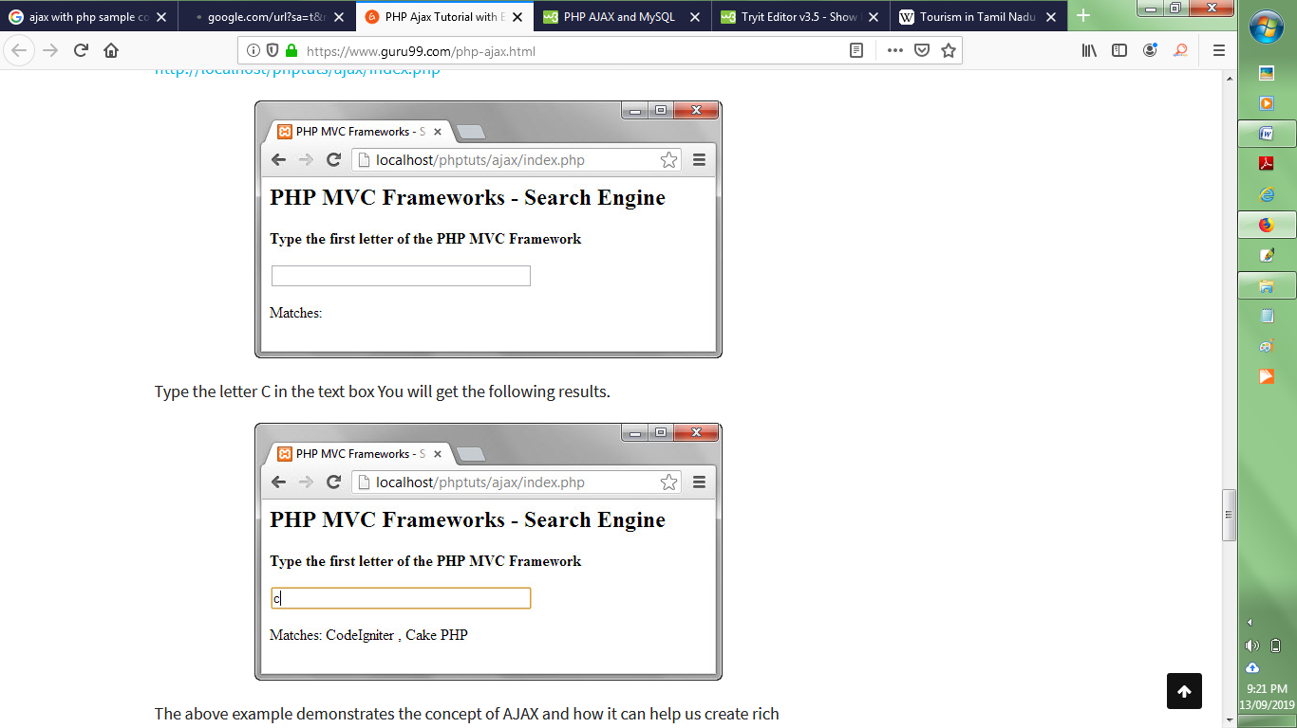



**Result:**

Thus a web page is developed to implement autocompletion of a textbox using AJAX and PHP.

**Viva Questions**

1. Create a connection with PHP server using AJAX and display a welcome message received from the server.
2. Find the length of the given name using PHP and AJAX without loading page.
3. Reverse the given number using PHP and AJAX.
4. Retrieve city name while using the pincode using AJAX and PHP
5. Create a AJAX program to display the student when user type department name without refreshing the page.
6. Create a AJAX program to search a faculty details based on name/ email/mobile number.
7. Create a AJAX program to dynamically add product details
8. Write a program to check the given email id is already registered  or not using AJAX
9. Dynamically load the list of district when user choose the state from the list using PHP and AJAX
10. Retrieve the user detail (name, email, mobile and address) in JSON format from server based on mobile number and load the existing details in form using PHP and AJAX. Also provide the facility to update the email and address.

**Experiment 10:**

**DATABASE CONNECTIVITY FOR EMPLOYEE DETAILS USING PHP**

**Aim:**

To develop an Web application to maintain the Employee Database using PHP

**Description:**

* + - * <style> - Define style information for an HTMLdocument.
      * <?php ?>-php start and endtag
      * Extract()-Imports variables into the local symbol table from an array
      * Die() - Prints a message and exits the currentscript
      * Mysql_connect()-Open a connection to MYSQLserver
      * Mysql_querry() –Execute the given querry and return theresult
      * Mysql_error() -Returns the last error description for the most recent functioncall
      * Mysql_fetch_row()-Fetches one row from aresult-set
      * Mysql_close()-Terminate the connection to mysqlserver

**Program:**

<html>

<head>

<title>EMPLOYEE DETAILS</title>

<style type="text/css">body{

}

table{

}

font-family:arial; background-color:cyan;

background-color:pink;

td{ padding-top:2px;

border-style:inset;

padding-left:2px;padding-right:2px; border-width:1px;

}

</style>

</head>

<body>

<?php

extract( $_POST );

//$query = "SELECT * FROM emp";

$query = "SELECT " . $name ." FROMemp";

//$query="INSERT INTO emp(Emp_id,Emp_name,Dob,Designation,Department,Hire_date,Salary)values('102','Sindhu','1 997-07-22','Senior manager','Accounts','2013-02-04','30000')";

//$query="INSERT INTO emp(Emp_id,Emp_name,Dob,Designation,Department,Hire_date,Salary)values('103','SARATHI ','1997-07-25','Senior manager','Accounts','2015-05-04','35000')";

//$query="UPDATE emp SET Designation='senior Sales executive' WHERE emp_id='103'";

//$query="DELETE FROM emp WHERE emp_id='102'";

if( !( $database = mysql_connect( "localhost", "student", "student" ) ) ) die( "could not connect to database </body></html>" );

if( !mysql_select_db( "employee", $database ) )

die( "could not connect to database </body></html>" ); if( !( $result = mysql_query( $query , $database ) ) )

{

print ( "<p>could not execute query</p>" ); die(mysql_error()."</body></html>" );

}

mysql_close( $database );

?>

<table>

<?php

for ( $counter = 0; $row = mysql_fetch_row( $result ); $counter++ )

{

print( "<tr>" );

foreach ( $row as $key => $value ) print( "<td>$value</td>" );

print( "</tr>" );

}

?>

</table>

<br />

search yield <strong><?php print( "$counter" ) ?> results<br /><br /></strong>

</body>

</html> EMPLOYEE

<html>

<head>

<title> EMPLOYE FORM </title>

<style type="text/css"> body

{

background-color:pink;}

</style>

</head>

<body>

<h2 ALIGN="CENTER"><b>EMPLOYEE DETAILS </b></h2>

<form method="post" action="employeedb.php">

<p><b>Select a Field to Display:

<input type="text" name="name" />

<input type="submit" value="Send Query" />

</form>

</body>

</html>

**Output:**

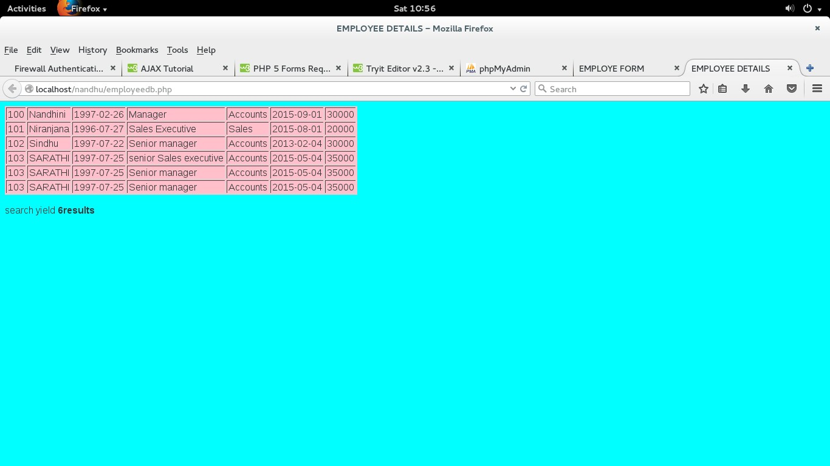

**Result:**

Thus a web application to maintain employee details using PHP and MySQL has been developed.

**Viva Questions**

1. Establish a connection with MySQL database server display connection success message and create a database using PHP
2. Write a PHP  program to create  and delete a table into a existing MySQL database
3. Alter a table column (Add/ remove /update) and display the table description using PHP program
4. Write a PHP and MySQL program collect the data from user form and insert into the table display appropriate success or failure message.
5. Write a PHP program to retrieve information from a table
6. Write a PHP program to update a email address of an student using his roll number in student table.
7. Delete a customer information based on customer id using PHP
8. Write a PHP program to count the number of records in a table.
9. Select the student records based on department from student table using PHP program
10. Write a PHP program to search a book based on given title

# Experiment 11:

**USER SIGNIN FORM USING SESSION TRACKING**

**Aim:**

To perform registration of user of new user and signin using session tracking

# Description:

* A session is started with the session_start()function.
* Session variables are set with the PHP global variable:$_SESSION.

**STEPS:**

1. Start the session using the function session_start()
2. Set session variable $_SESSION["var_name"] = value;
3. Use isset () function to check whether a variable is set or not.
4. unset session session_unset() or destroy all session variables session_destroy()
5. unset() function destroys a given session variable

# Program:

*Index.php*

<?php session_start();

if(isset($_POST["LOGIN"]))

{$_SESSION['name']=$_POST['user'];

$_SESSION['password']=$_POST['pass'];

$_SESSION['repassword']=$_POST['word']; header("location: login.php");

}

?>

<?php if(isset($_POST['LOGIN']))

{

$user = $_POST['user'];

$pass = $_POST['pass'];

$word = $_POST['word'];

if($user == $_POST['user'] && $pass == $_POST['pass'] && $word ==

$_POST['word'])

{

$_SESSION['name']=$user;

echo '<script type="text/javascript">

window.open("login.php","_self");</script>';

}

else

{

echo "invalid UserName or Password";

}

}

?>

<html>

<head>

<style> h1{ color:blue;

align=center;}

</style>

<script type='text/javascript'> function validate(field, query)

{

xmlhttp = new XMLHttpRequest(); xmlhttp.onreadystatechange = function()

{

if(xmlhttp.readyState = = 4 && xmlhttp.status==200)

{

document.getElementById(field).innerHTML = xmlhttp.responseText;

document.getElementById(field).innerHTML = "Validating..";

}

else{

document.getElementById(field).innerHTML = "Unknown Error

Occurred. <a href='index.php'>Reload</a> the page.";

}

}

xmlhttp.open("GET","check.php?field="+field+"&query="+query, true); xmlhttp.send();

}

</script>

</head>

<body>

<form action="login.php" method='post'>

<h1><b>REGISTRATION FORM</b></h1>

<table>

<tr>

<td>Username</td>

<td><input type='text' name='user' onchange="validate('u',this.value)"></td>

<td><div id='u'></div></td>

</tr>

<tr>

<td>Password</td>

<td><input type='password' name='pass' onblur="validate('p',this.value)"></td>

<td><div id='p'></div></td></tr>

<tr>

<td>ReType-Password</td>

<td><input type='password' name='word' onblur="validate('r',this.value)"></td>

<td><div id='r'></div></td></tr>

<tr>

<td>Gender</td>

<td><input type='radio' name='gender'value='male' onblur="validate('q',this.value)">Male</td><br>

<td><input type='radio' name='gender' value='female'

onblur="validate('q',this.value)">Female</td>

<td><div id='q'></div></td></tr>

<td> E-mail</td>

<td><input type="email" pattern="[a-z0-9._%+-]+@[a-z0-9.-]+\.[a-z]{2,3}$" placeholder="Enter your mail id" required ></td>

</tr>

<tr>

<td> Phone number </td>

<td><input type=tel pattern="[0-9]{10}" placeholder="Enter your phone number" required

></td>

<tr>

<tr>

<td> Address</td>

<td><input type="text" placeholder="Enter your address" required ></td>

</tr>

</table>

<input type='submit' value='CREATE NEW ACCOUNT' >

</form>

</body>

</html>

# *Check.php*

<?php

$query = $_GET['query'];

$field= $_GET['field']; if($field == "u")

{

$username = array("niru", "sacros");

if(in_array($query, $username))

echo "<font color=red>Username already exists</font>"; else

echo "<font color=green>Username is valid</font>";

}

else if($field == "p")

{

if(strlen($query) < 6)

echo "<font color=red>Password too short</font>"; else

echo "<font color=green>password is valid</font>";

}

else if($field == "m")

{

if(!preg_match("/([\w\-]+\@[\w\-]+\.[\w\-]+)/",$query))

echo"<font color=red>invalid email</font>"; else

echo"<font color=green>valid</font>";

}

else if($field =="n")

{

if (!preg_match("/\b(?:(?:https?|ftp):\/\/|www\.)[-a-z0-9+&@#\/%?=~_|!:,.;]*[-a-z0- 9+&@#\/%=~_|]/i", $query))

echo"<font color=red>invalid website</font>"; else

echo"<font color=green>valid</font>";

}

?>

# *Login.php*

<?php

session_start();

?>

<?php

if(isset($_POST['LOGIN']))

{

$user=$_POST['user'];

$pass=$_POST['pass'];

if($user == $_POST['user'] && $pass == $_POST['pass'])

{

$_SESSION['name']=$user;

echo '<script type="text/javascript">window.open("profile.php","_self"); </script>';

}

else

{

echo "invalid";

}

}

?>

<html>

<head>

</head>

<body>

<h1>LOGIN FORM</h1>

<form method="POST">

<b>Name:</b><br><input type=text name="user" required /><br>

<b>Password:</b><br><input type=password name="pass" required /><br>

<b>RePassword:</b><br><input type=password name="word" required /><br>

<button type="submit" name="LOGIN">Submit</button>

</form>

</body>

</html>

# *Logout.php*

<?php session_start(); print_r($_SESSION);

if(isset($_SESSION['name']))

{

unset($_SESSION['name']);

}

echo '<h1>You have been successfully logout</h1>';

?>

<html>

<head>

<h1><?php echo $name;?></h1>

<h3><a href="login.php">Click here to go back..</a></h3>

</html>

# *Profile.php*

<?php

session_start(); if(!isset($_SESSION['name']))

{

header("location: index.php");

}

$name=$_SESSION['name'];

?>

<html>

<head>

<title>Welcome <?php echo $name;?></title>

</head>

<h1>Hi.......<?php echo $name;?></h1>

<img src="index.jpg">

<h3><a href="logout.php">Click Here to log out</a></h3>

</html>

**Output:**

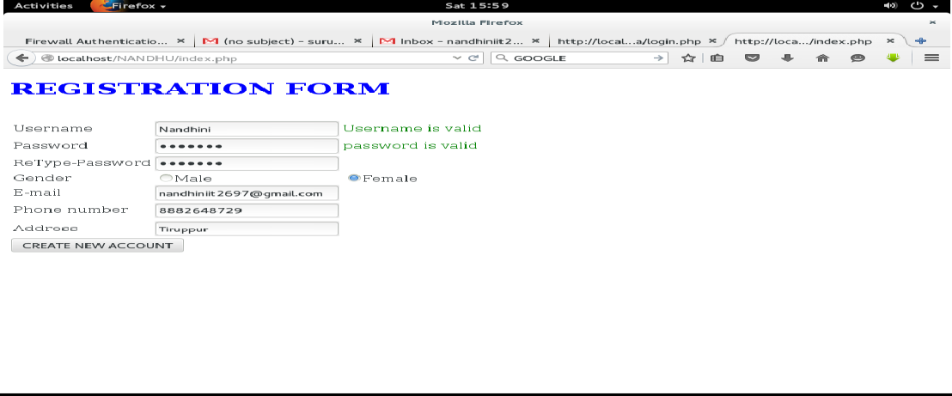

**Result:**

Thus a web page for user sign-in was developed using session tracking in PHP.

**Viva Questions:**

1. Why do we use session in PHP?
2. Write a PHP code to initiate a session in PHP?
3. Write a PHP code to access session variables in PHP?
4. Write a PHP code to check if session variable is already set or not in PHP?
5. How will you unset a single session variable?
6. Write a PHP script to destroy all session’s variable?
7. When do sessions end?
8. What is the default session time in PHP?
9. Write a PHP script to maintain the number of page views to the web site
10. **How are sessions better than cookies?**

**Experiment 12:**

**DEVELOP AN ONLINE RESERVATION SYSTEM USING JAVASCRIPT, CSS, AJAX, PHP, AND MYSQL WITH SESSION TRACKING**

**Aim:**

To design and display online reservation system using javascript,css,ajax,php,mysql with session tracking.

**Description:**

* **$_SERVER["PHP_SELF"] -** The $_SERVER["PHP_SELF"] is a super globalvariable that returns the filename of the currently executingscript.

# Open a Connection to the MySQLServer

* mysqli_connect(host,username,password,dbname);

# Close aConnection

* mysqli_close($con);

**STEPS:**

1. Establish connection to MySql Server with username and password of server
2. Select the necessary database from the database server
3. Frame the necessary queries (insert(),select(),update(),delete() as a sting
4. Execute the query using mysqli_query()
5. Select and retrieve and display the records using mysqli_fetch_assoc()
6. Close the connection Mysqli_close()

# Program:

# *LOGIN:*

<html>

<body>

<form action="login.php" method="post"> User name:

<input type="text" name="name"> Password:

<input type="text" name="pw">

<br>

<input type="submit" value="submit">

</form>

</body>

</html>

# *INSERT:*

<html>

<body>

<form method="post" action="insert.php"><br> rollno:

<input type="text" name="rollno"><br> name:

<input type="text"name="name"><br> m1:

<input type="text"name="m1"><br> m2:

<input type="text"name="m2"><br> m3:

<input type="text" name="m3"><br>m4:

<input type="text"name="m4"><br> m5:

<input type="text"name="m5"><br> m6:

<input type="text" name="m6"><br>

<input type="submit" value="submit">

</form>

</body>

</html>

# *INDEX:*

<html>

<head>

<style > body

{background-color:"yellow";} table

{

margin:2em;

border-color:"black";

}

</style>

<script type='text/javascript'> function validate(field, query)

{

xmlhttp = new XMLHttpRequest();

xmlhttp.onreadystatechange = function()

{

if (xmlhttp.readyState!=4 && xmlhttp.status==200)

{

document.getElementById(field).innerHTML = "Validating..";

}

else if (xmlhttp.readyState==4 && xmlhttp.status==200)

{

document.getElementById(field).innerHTML = xmlhttp.responseText;

}

else

{

document.getElementById(field).innerHTML ="Unknown Error Occurred.

<a href='index.php'>Reload</a> thepage.";

}

}

xmlhttp.open("GET","check.php?field="+field+"&query="+query, false); xmlhttp.send();

}

</script>

</head>

<body bgcolor="grey">

<h2 font-color="red"><marquee><u><i>REGISTRATION FORM</i></u></marquee></h2>

<form action="submitted.html" method='post' font color="white" >

<table>

<tr>

<td>Username</td>

<td><input type='text' name='user' onchange="validate('u',this.value)"></td>

<td><div id='u'></div></td>

</tr>

<tr>

<td>Password</td>

<td><input type='password' name='pass' onblur="validate('p',this.value)"></td>

<td><div id='p'></div></td> </tr>

<tr>

<td>phone number</td>

<td>

<input type='text' name='phone' onblur="validate('ph',this.value)"> </td>

<td><div id='ph'></div></td> </tr>

<tr>

<td>gender</td>

<td><input type='radio' name='gender' onblur="validate('male',this.value)"></td>

<td><div id='male'></div></td>

<td><input type='radio' name='gender' onblur="validate('female',this.value)"></td>

<td><div id='female'></div></td> </tr>

<tr>

<td>qualificaton</td>

<td><input type='text' name='q' onblur="validate('q',this.value)"></td>

<td><div id='q'></div></td> </tr>

<tr>

<td>university</td>

<td><input type='text' name='un' onblur="validate('un',this.value)"></td>

<td><div id='un'></div></td></tr><br><p>//enter the country name as 'India'</p>

<tr>

<td>country</td>

<td><input type='text' name='c' onblur="validate('c',this.value)"></td>

<td><div id='c'></div></td></tr>

</table>

<input type='submit' value='Submit'>

</form>

</body>

</html>

# *FETCH:*

<?php

function grade($var)

{

if($var>=90)

{

$g="S";

}

if($var<=89 && $var>=80){

$g="A";}

if($var<=79 && $var>=70){

$g="B";}

if($var<=69 && $var>=60){

$g="C";}

if($var<=59 && $var>=55){

$g="D";}

if($var<=54 && $var>=50){

$g="E";}

if($var<50){

$g="RA";}

return$g;

}

$con =mysql_connect("localhost","student","student"); if(!$con)

{

die('could not connect : '.mysql_error());

}

mysql_select_db("db1",$con);

$r=$_POST['rollno'];

$result=mysql_query("SELECT * FROM mark where rollno='$r'");

while($row = mysql_fetch_array($result))

{

echo '<table border=1px>

<tr>STUDENT MARK DETAILS</tr>

<tr><td>ROLL</td><tdcolspan=2>'.$row['rollno'].'</td></tr>

<tr><td>NAME</td><tdcolspan=2>'.$row['name'].'</td></tr>

<tr><td>Mark1</td><td>'.$row['m1'].'</td><td>'.grade($row['m1']).'</td></tr>

<tr><td>Mark1</td><td>'.$row['m2'].'</td><td>'.grade($row['m2']).'</td></tr>

<tr><td>Mark2</td><td>'.$row['m3'].'</td><td>'.grade($row['m3']).'</td></tr>

<tr><td>Mark4</td><td>'.$row['m4'].'</td><td>'.grade($row['m4']).'</td></tr>

<tr><td>Mark5</td><td>'.$row['m5'].'</td><td>'.grade($row['m5']).'</td></tr>

<tr><td>Mark6</td><td>'.$row['m6'].'</td><td>'.grade($row['m6']).'</td></tr>

</table>';

}

mysql_close($con);

?>

# *UPDATE:*

<html>

<?php session_start();$hi=$_SESSION['login']; echo $hi;

?>

<body>

<form method="post"action="update.php">

Roll no:

<input type="text"name="name"><br> m1:

<input type="text"name="m1"><br> m2:

<input type="text"name="m2"><br>

m3:

<input type="text" name="m3"><br>

<input type="submit" value="submit">

</form>

</body>

</html>

# *DELETE:*

<?php

$v1=$_POST['rollno'];

$v2=$_POST['name'];

$v3=$_POST['m1'];

$v4=$_POST['m2'];

$v5=$_POST['m3'];

$v6=$_POST['m4'];

$v7=$_POST['m5'];

$v8=$_POST['m6'];

$con=mysql_connect("localhost","student","student"); mysql_select_db("mark",$con);

$query="DELETE FROM mark WHERE rollno='$v1';"; mysql_query($query,$con);

echo "delete successfully"; mysql_close($con);

?>

<html>

<body>

session_start();

<form action="fetch.php" method="post"> ROLL NO:

<input type="text" name="rollno">

<input type="submit" value="submit">

</form>

</body>

</html>

# SESSION:

<?

session_start();

$server = "localhost";

$username ="Santhosh";

$password ="Santhosh";

$db_name = "stud_db";

$db = mysql_connect($server,$username,$password) or die("Connection to database failed, perhaps the service is down !!");

mysql_select_db($db_name) or die("Database name not available !!");

$login = mysql_query("select * from users where (username = '" . $_POST['username'] . "') and (password = '" .md5($_POST['password']) . "')",$db);

$rowcount = mysql_num_rows($login); if ($rowcount == 1) {

$_SESSION['username'] = $_POST['username']; header("Location: securedpage.php");

}

else

{

header("Location: loginpage.php");

}

?>

# *PAGE:*

<?php session_start();

$temp=$_SESSION['login']; echo "WELCOME<br>".$temp;

echo "<a href=insert.html>INSERT</a><br>"; echo "<a href=update.html>UPDATE</a><br>"; echo "<a href=delete.html>DELETE</a><br>"; echo "<a href=result.html>SELECT</a><br>"; echo "<a href=logout.php>LOGOUT</a><br>";

?>

**Output:**

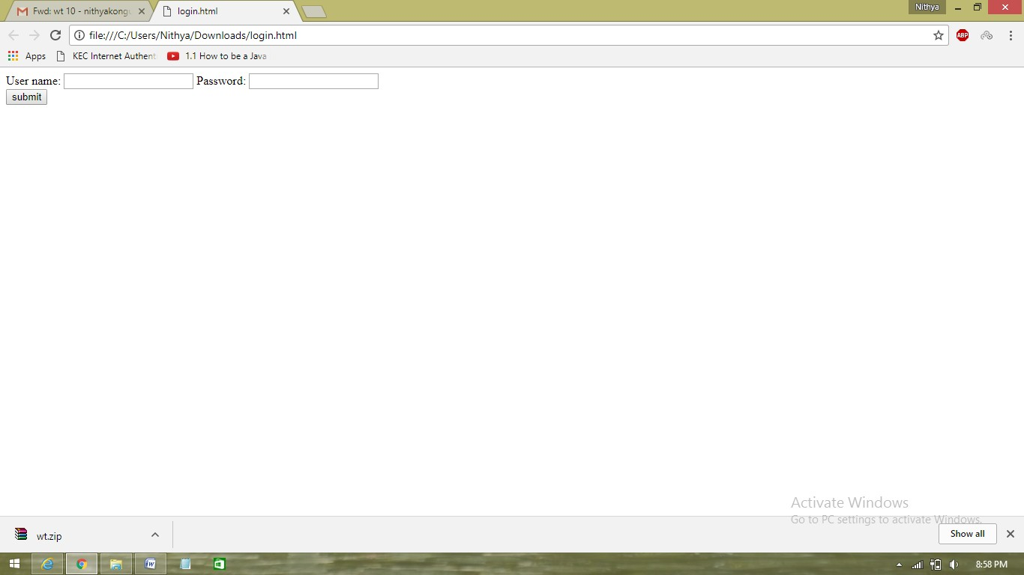

**Result:**

Thus an online reservation system using JavaScript, CSS, AJAX, PHP, and MySQL has been developed.

**Viva Questions**

1. Design necessary db and tables for implementing online store management system
2. Design a catalogue page to display the products details dynamically based on the category ,sub category using css and java script
3. Design form to read the product details of a store and validate using JavaScript and insert to the database
4. Write a PHP script to create session for user and track the products ordered by the user
5. Write a PHP script to destroy the particular user details when user logout of the web site
6. Create PHP script to display the student when user type department name without refreshing the page using Ajax.
7. Create a PHP script to search a product details based on price and offers using Ajax
8. Create a AJAX program to dynamically delete/update product details
9. Write a program to check the given phone number is already registered or not using AJAX
10. Write a PHP script to dynamically load the list of products when user choose the category from the list using PHP and AJAX